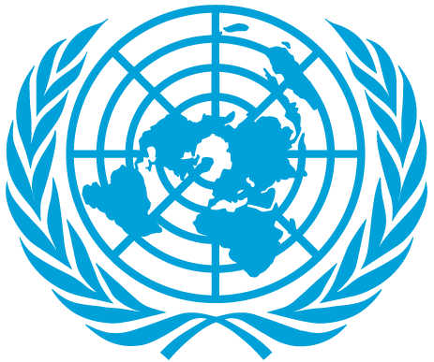 | 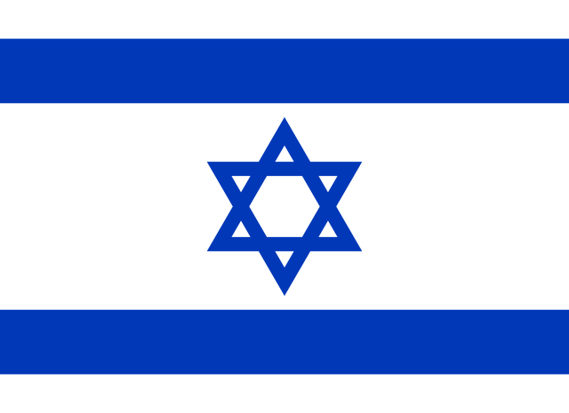

COUNTRY: Israel
COMITTEE: DISEC
TOPIC: Prohibition of Biological and Chemical Weapons

State of Israel’s and Jewish people’s history is scarred with wars, massive deportations and massacres. These events in our history etched into the consicousness of our people. State of Israel is located in the one of the most destabilized places on earth. Ongoing wars and conflicts remain as a huge treat for the future of Middle Eastern countries such as Israel. Although being in a such place Israel remain as a economically developing, thriving Parliamentary democracy . But that was not always the case about Jewish people. In the period of 1941-1945 Nazi Germany systematically murdered six million (Estimated) Jews in Europe that was 2/3 of the Europe’s Jewish population at that time. That was not an ordinary holocaust. Researches and documents Show that Nazi scientists were commiting horrible crimes and doing inhumane experiments in concentration camps. Furthermore at that time the similar holocaust was taking place in the Japanese-occupied Manchuria. Both of these unordinary holocausts has known for usage of Chemical and Bilogical weapons in the concentration camps. With these experiences have been told, we do want to implement serious restrictions against the Chemical and Biological Warfare.
State of Israel’s efforts against Biological and Chemical Warfare can be seen in every angle and perspective. One of those efforts was signage of the Chemical Weapons Convention of 1993 (CWC) . Modern State of Israel’s policy against Biological an Chemical Warfare also can be seen through the attitude towards the modern history conflicts such as Iraq-Iran War (1980-1988) and Syrian Civil War (2011-Present) and many more. We do assume that UN is not implementing restrictions that are enough deterrent. Moreover UN should play a more significant role in investigating Chemical and Biological researches made by countries. Restriction of WMDs are not less important then these topics. We clearly see the importance of the restriction of these weapons and it is no doubt that as a delegate of a country that has been suffered and seen its devastating consequences work hardly as we could. Lastly State of Israel remains and will be remaining as a country against every bad action against civilians and World peace.

