**Country:** Chile



**Committee:** Food and Agriculture Organization (FAO)

**Agenda Item:** Strategies for Advancing Sustainable Agricultural Practices in the Green Transition



Chile officially the Republic of Chile situated along the western seaboard of South America. It is the southernmost country in the world and the closest one to Antarctica. It shares borders with Argentina, Bolivia, Peru and Pacific Ocean. Chile exercises sovereignty over Easter Island, the Juan Fernández Archipelago, and the volcanic islets of Sala y Gómez, San Félix, and San Ambrosio, all of which are located in the South Pacific. The capital of Chile is Santiago, it is also the largest city and has the highest population of any city in Chile. The national language is Spanish.

Agriculture is at the base of food security and economic stability in all countries, and this includes Chile. However, traditional agricultural practices have caused significant environmental harm, such as soil degradation, loss of biodiversity, and pollution. All these problems are worsened by adverse climate effects and pressure to increase food production.

The green transformation offers the chance to improve the agricultural system to become more sustainable and resilient. It would be by using environmentally sound practices that allow for lower emissions of greenhouse gases into the atmosphere, water conservation, and building ecosystems while producing food for the coming generations. All this is to be accompanied by positive persistent challenges-inefficient policies, imbalanced resource access, and out-of-date technology.

Chile is committed to advancing sustainable agricultural practices as part of its national strategy to combat climate change and protect its rich biodiversity. Agriculture is a key sector of our economy, particularly in the export of grapes, apple and wine. Grape production in 2022 is 2 million 4 hundred thousand units. Chile ranks 8th in the grape production ranking of countries. However, we are also facing challenges. Chile's relief is mostly mountainous with the Andes range dominating the landscape. Due to the country's extreme length, Chile has a wide variety of climates, from the coastal desert starting in the tropical north to the frigid subantarctic southern tip. Impacts of climate variability is also a challenge for advancing sustainable agricultural practices. Water scarcity and soil degradation are also among these challenges.  
  
Chile is also confronting environmental issues such as air and water pollution, deforestation, and soil degradation, climate change which are exacerbated by improper waste disposal and industrial activities. Despite these challenges, Chile actively participates in international agreements like, Antarctic Treaty, Convention of Biological Diversity (CBD), United Nations Framework Convention on Climate Change (UNFCCC) to address these concerns on a global scale.   
  
Currently, Chile dedicates 21.1% of its land to agriculture, with arable land accounting for 1.7%. Forests cover 21.9% of the nation, providing critical ecosystems that need protection against deforestation. Chile’s agricultural lands are decreasing. It is important to take precautions for decreasing, otherwise this could be a problem for green transition. Additionally, Chile’s urban population, which makes up 88% of the total population, highlights the need for efficient urban-agricultural balance to ensure sustainability.

Agricultural Lands

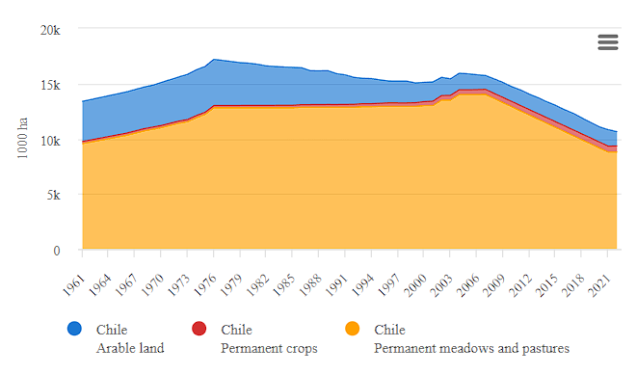1.1  
  
Responding to these issues, Chile has undertaken measures such as the promotion of organic agriculture, the use of irrigation techniques that consume less water, and the reforestation of degraded lands. Pursuant to its Nationally Determined Contributions under the Paris Agreement, Chile has committed to mitigating carbon emissions and enhancing sustainable land use. All this work indicates that Chile admits the barriers constantly surfacing need more international cooperation and creativity.

Chile proposes the following actions to promote sustainable agriculture:

* • Implement stricter regulations on overuse of harmful chemicals.
* Provide training programs for smallholder farmers to adopt climate-smart techniques, such as crop rotation, agroforestry, and conservation agriculture.
* Increase access to funding and resources, particularly for small-scale farmers, to enable their transition to sustainable practices.
* Support research and development of drought-resistant crops and technologies tailored to Chile’s diverse climate zones.
* Encourage the use of precision agriculture to improve efficiency and reduce waste.
* Partner with FAO and other international organizations to secure funding for sustainable agricultural projects.
* Facilitate knowledge-sharing initiatives, particularly regarding water management and climate adaptation strategies
* Implement systems to recycle organic waste into compost and bioenergy, reducing dependence on chemical fertilizers.
* Encourage sustainable aquaculture practices to minimize environmental impacts and enhance food security.
* Implement smart agricultural practices suitable for the soil by analyzing agricultural lands.

**References**

**-https://www.britannica.com/place/Chile/The-intermediate-depression**

**-https://www.mfa.gov.tr/sili-kunyesi.tr.mfa**

**-https://www.cia.gov/the-world-factbook/countries/chile/**

**-https://en.wikipedia.org/wiki/Chile**

**-https://www.fao.org/faostat/en/#rankings/commodities_by_country**

**-https://www.worldatlas.com/continents/south-america.html#countryList**

**-** Study Guide: HUTRAIN FAO Committee 2024.

- FAO Strategic Framework 2022-2031.

-1.1: **https://www.fao.org/faostat/en/#country/40**