**Country:**

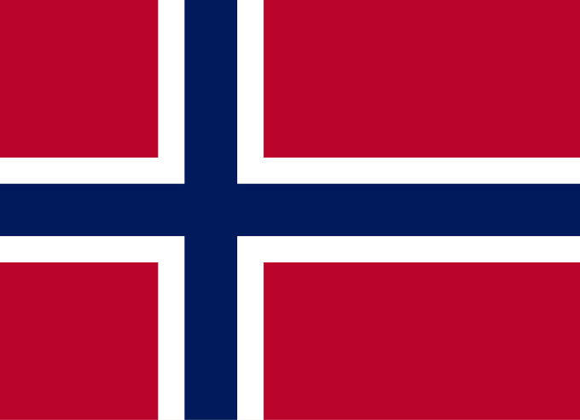

**The Kingdom Of Norway**

**Committee: United Nations Development Programme (UNDP)**

**Agenda Item: Strengthening Crisis Resilience Systems with Peacebuilding Initiatives and Conflict Prevention Strategies**

**School: Hacettepe University**

**Delegate: Defne Demirel**

The Kingdom Of Norway is a country of northern Europe that occupies the western half of the Scandinavian peinsula. Nearly half of the inhabitants of the country live in the far south, in the region around Oslo, the capital. About two-thirds of Norway is mountainous, and some 50,000 islands. Lying on the northern outskirts of the European continent and thus avoiding the characteristics of a geographic crossroads, Norway (the “northern way”) has maintained a great homogeneity among its peoples and their way of life. Overwhelming majority of the country’s inhabitants are ethnically Nordic. The main political division reflects differing views on the importance of free-market forces; but the socialists long ago stopped insisting on nationalization of the country’s industry, and the nonsocialists have accepted extensive governmental control of the country’s economy. National consensus was a major factor in the rapid growth of Norway as an industrial nation during the 20th century and in the creation of one of the highest standards of living in the world, reinforced by a comprehensive social welfare system. Norway’s outstanding natural beauty has attracted visitors from all over the world. Playwright Henric Ibsen said, “The magnificent, but severe, natural environment surrounding people up there in the north, the lonely, secluded life—the farms are miles apart—forces them to…become introspective and serious… At home every other person is a philosopher!” about Norway.

The growing importance of strengthening global crisis resilience systems and promoting sustainable peace through collaboration and transparency are crucial matters for us. Norway’s peace and reconciliation efforts are varied and depend on the both global and local conditions as you can observe from the fact that Norway is a longstanding supporter of the Peacebuilding Fund (PBF) and committed partner of the Peacebuilding Commission (PBC). As one of the top voluntary contributors of the PBF, Norway is hosting the Annual Strategic Dialogue with the PBF’s top twelve voluntary donors As one of the largest and multi-year donors to the PBF, Norway’s contribution over 52 million dollar aligns with our continuous emphasis on preventing and resolving conflicts as well as our strong diplomatic engagement to bring a sustainable peace in the world’s most affected conflict regions. Norwegian peace diplomacy includes discretion, impartial faciliation, inclusion, readiness to speak with everyone, long-term willingness to assist,resources to assist, close collaboration with partners and acceptance of taking risks. Norway recognizes the importance of local ownership and the essential role of the whole of society, including women and youth, in contributing to peacebuilding. Norway’s contribution to the PBF enabled it to support 3,000 young citizens in Mali with civic education and conflict management training, resulting in the systematic inclusion of youth representatives in 66 per cent of local conflict management structures in 2023, against 39 per cent in 2020. Norway’s contribution to the Peacebuilding Fund reiterates Norway’s commitment to strengthening women’s meaningful participation in all parts of the peace continuum, a critical contribution to sustainable peace. For instance, in the Gambia, PBF’s investments helped to enhance the awareness of women’s rights and potential as political leaders ahead of the 2023 local elections.

As a strong advocate for the United Nations' peacebuilding agenda, Norway supports a holistic approach that integrates humanitarian aid, sustainable development, and human rights. Norway believes that building resilient communities and addressing the root causes of conflict are essential for long-term stability and prosperity. We emphasize the importance of addressing systemic inequalities, ensuring gender equality, and fostering trust between governments and local communities. Norway proposes enhancing early warning systems and collobaration between UNDP that will ensure timely interventions. Strengthening the capacity of local governments and civil society organizations to respond to crises is essential. Norway emphasizes the need for inclusive training programs that prioritize marginalized groups, including women and youth. Norway encourages UNDP member states to commit more resources to the Peacebuilding Fund (PBF) that focus areas should include education, healthcare, and economic opportunities to address the root causes of instability. Norway is confident that a unified, inclusive, and innovative approach can create a more resilient and peaceful world.

SOURCES

<https://www.regjeringen.no/en/topics/foreign-affairs/peace-and-reconciliation-efforts/innsiktsmappe/norway-peace-work/id446704/>

<https://www.britannica.com/place/Norway/Agriculture-forestry-and-fishing>