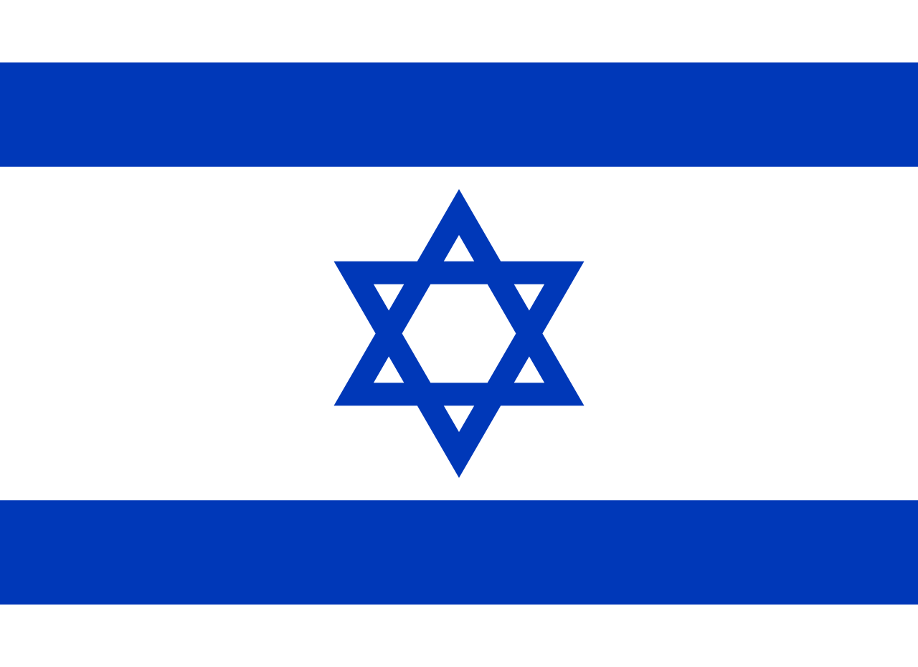

Committee: Disarmament and International Security Committee (DISEC)

Country: Israel

Topic: The Impact of Arms Trafficking in the Sahel Region and Surrounding Areas

The State of Israel is recognizes this major problem, problem that is caused by arms trafficking to the Sahel region and surrounding countries, that threatens the integrity of the Sahel region and surrounding areas. Arms trafficking encourages terrorism, lightens the effect of the government and endangers civilian lives. The State of Israel is eager to collaborate with international partners to overcome this issue.

Trafficking of arms to the Sahel region increases the effect of life threatening acts. The supply of arms also increases violence, abuses human rights and influences international trade negatively. Illegal arms trafficking also causes poverty and increases criminal acts. Sahel region countries are mostly getting their income from exporting agricultural products. Arms trafficking causes these governments to focus mainly on preventing arms trade economically rather than promoting agricultural products and farming, which decreases the annual imports gradually. Terrorist groups such as Al-Qaeda and Boko Haram that are getting supplied by arms trafficking which weakens the border security of the countries in Sahel. These acts cause humanitarian crises, abuse of rights, an increasing crime rate and the integrity of Sahel countries to get jeopardized.

Promoting and enhancing collaborations internationally allows countries to elevate border security and share solutions. Besides supporting international programs such as the UN Programme of Action to Prevent, Combat and Eradicate the Illicit Trade in Small Arms and Light Weapons (PoA) one of the possible effective ways to enhance collaboration. Encouraging the countries of the Sahel region to enforce and apply regulations that are prepared internationally to strenghten legal frameworks. In addition, providing the countries of the Sahel region with economical and technical assistance. Technical assistance includes training programs to all countries that are in Sahel to inform civils.

The State of Israel is ready to collaborate internationally with other nations to combat arms trafficking in the Sahel region. We call out all the member states to put efforts in order to deactivate trafficking networks and address other problems that cause arms trafficking. In order to provide calmness and serenity to the Sahel region, collaboration is a must.