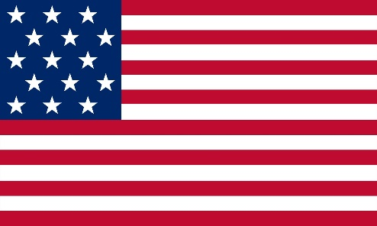COUNTRY: United States of America

COMMITTEE: United Nations Office on Drugs and Crimes

AGENDA ITEM: Combating Human Trafficking for Organ Removal

The United States of America (USA), is a country located in North America, it is a federation of 50 states along with its capital is Washington, DC and is a federal republic and governed by presidential system. The USA has the world's third largest population with a population of 334 million. The national language is English and its currency is the American Dollar. The USA’s population includes people from countless ethnicity and religions.

Organ trafficking is a crime defined under the laws of many countries and international law. People who sell their organs to make money in the black market consciously, the ones who organise this sales and processes of transplant and those who buy these organs are all guilty. However, human trafficking for organ removal is one of the biggest challenges that UNODC should focus on, as it exploits the human rights of people in underdeveloped countries by trading their organs for benefits of certain organizations or forces illegally. According to the statements of the World Health Organization (WHO), it is known that the illegal organ mafia sells 10.000 black market organs every year.

Human trafficking for organ removal should not only be considered as a black market problem but also a major challenge on criminal justice and a problem of vulnerable victims. On the contrary this issue is both a human rights violation and a very dangerous form of human trafficking. And the focus of this issue should be on the safety of victims and the improvement of their psychological and physical health in order to prevent their rights.

The main challenges faced by victims of human trafficking for organ removal are mostly medical and psychological distress which are caused by the tough and unsafe conditions of the organ transplant process. Operations which are performed by non-professionals and under unhygienic conditions may cause major medical problems such as permanent scars, excessive blood loss and tissue inflammation in donors, and for the recipients it is quite possible that problems such as blood incompatibility, diseases spread from organs coming from unhealthy donors and incorrect treatment processes to be observed.

The United States prioritized the fight against human trafficking and published The National Action Plan to Combat Human Trafficking in order to identify and investigate traffickers, ensure the safety and create safe environments for victims and prevent this crime. This plan mainly highlights the importance of fighting against human trafficking and outlines the plan that USA is going to adhere for the next three years comprehensively by giving certain informations about; the ways to strenghten the investigations of traffickers to ensure combating human trafficking, improving the protection of victims which suffers from mental or physical distresses caused by organ removal process and prevent crimes involving human trafficking within its borders and abroad.

The National Action Plan to Combat Human Trafficking provides information about various types of human trafficking and presents the plan that the USA will adhere to in the next three years in dealing with the problems mentioned in the previous paragraphs.

However, in order to end human trafficking for organ removal all over the worls, member states shall create and adhere to a common plan with the support of NGO’s and organizations serving in this field, inform vulnerable citizens in underdeveloped regions, identify and investigate traffickers and give victims of the trafficking the mental and the physical help they need.

Bibliography:

* <https://www.unodc.org/unodc/en/human-trafficking/faqs.html>
* <https://www.state.gov/humantrafficking/>
* <https://www.bbc.com/news/65960515>
* <https://link.springer.com/article/10.1007/s11019-013-9488-y>
* <https://www.interpol.int/News-and-Events/News/2021/North-and-West-Africa-INTERPOL-report-highlights-human-trafficking-for-organ-removal>
* <https://international-review.icrc.org/articles/harvesting-vulnerability-the-challenges-of-organ-trafficking-in-armed-conflict-923>
* <https://www.coe.int/en/web/anti-human-trafficking/-/lauching-of-a-new-database-project-domestic-case-law-on-human-trafficking>
* <https://www.ncbi.nlm.nih.gov/pmc/articles/PMC4946496/>
* <https://www.youtube.com/watch?v=yUsd7Qs4NOk>
* <https://www.disrupthumantrafficking.com/?gad_source=1&gclid=Cj0KCQjw0MexBhD3ARIsAEI3WHL39qH9lwzZ-zNUUAUWpmEDZfO1z9i3RP2bhNuC8pBFGMGxc3UfJJgaAh8cEALw_wcB>