Country: North Korea

Committe: Social, Cultural and Humanitarian Committee (SOCHUM)

Agenda Item: Preserving freedom of press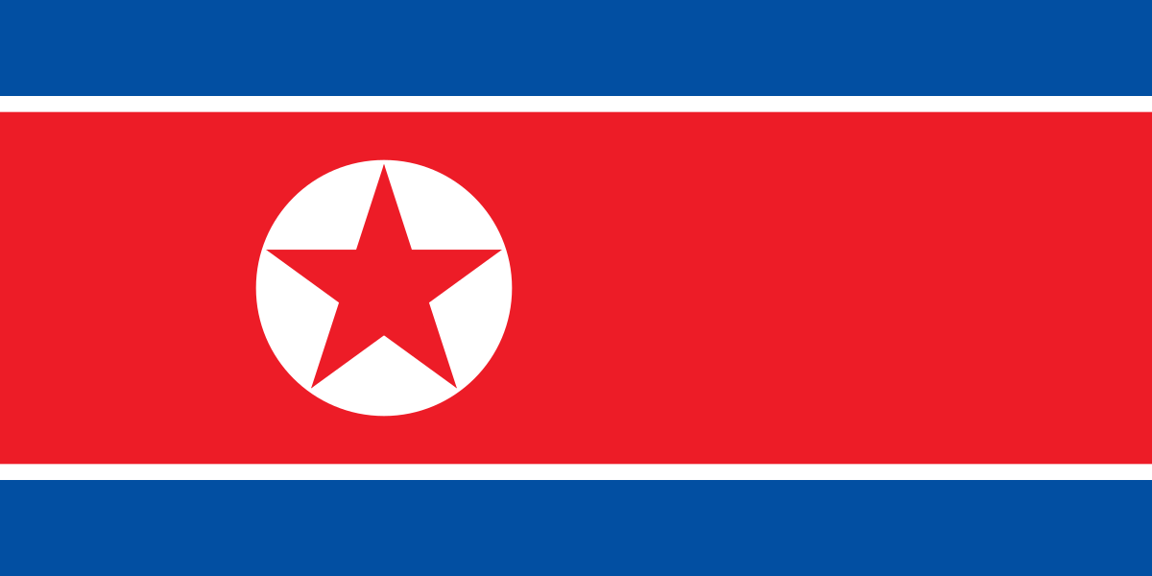

As The Democratic People’s Republic of Korea, we value the welfare of our people and want to protect the union of our country. North Korea’s constitution includes an article guaranteeing freedom of speech and press. However, we are concerned of the harm that unrestricted press may bring.

North Korea believes that unrestricted press can be used to spread hateful ideas. We are a country that wants to protect our people from any kind of trouble and negative intention. We do not want any kind of force to weaken our country or our socialist values so we support media outlets owned by the government.

Journalists are expected to report following the government’s line. We are strict on the information that comes and leaves the country as we want to protect our country from any kind of propaganda.

İpek Kamburoğlu