Kingdom of Sweden 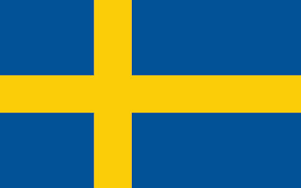
European Commission
European Union during 2015 (Immigrant Crisis)

Suppressed tensions in the Middle East, North Africa, and vicinity geographies have resulted in inevitable outgrows, which led to millions of people fleeing their homeland. By virtue of Europe's geopolitical location and socioeconomic welfare, it has been deemed as an unneglectable option for those who are in need of asylum. The immigrations that originate from underdeveloped countries and countries with political instability are taking place in divergent routes, via illegal organizations, which obstruct the safety of EU borders. The ongoing irregular migrations that had been rooting from those factors, weren't been able to get into control, eventuating unpleasant results for the host nations. The Kingdom of Sweden emphasizes the significance of taking progressive steps in order to both maintain the welfare of the refugees and EU countries' economic potential.
Sweden has invariably prioritized embracing policies towards foreigners in order to serve humanitarian rights. The noteworthy efforts are providing housing, education, and healthcare to refugees, as well as integration programs aiming to help refugees become self-sufficient members of society. Moreover, Sweden has consistently attested its commitment to supporting UNHCR, the United Nations Refugee Agency, by providing the largest contribution of untagged funds. This significant donation has contributed to addressing the humanitarian needs of the most vulnerable refugee populations. Regardless of Sweden's relatively low GDP, in comparison with the prominent EU members, the expenditures revolving around asylum of refugees have been demonstrated substantially higher by statistics, giving Sweden the credit of being one of the biggest spenders relative to GDP. Alas, probable financial adversities, the indefiniteness of asylums temporariness and its concern within the country have resulted in Sweden shifting its paradigm, to reducing the number of people taking shelter in the boundaries of the country, without altering the primacy of maintaining refugees’ prosperity and their integration.
Sweden advocates for more equitable distribution of refugees across EU member states based on factors such as GDP, population size, and existing capacity for integration. Comprehending the European Union as a united organization, and overcoming it jointly is essential for all nations Sweden also highlights the gravity of maximizing the border surveillance and security, with the intention of combatting illegal migrations and keeping the exodus under supervision. Taking EU countries' financial Powers into consideration, limiting the multitude of refugees is a mutualist status for expediencies of both sides and vital for the economical aspects of the host countries.

