**Country**: People’s Republic of Bangladesh

**Committee**: The United Nations Entity for Gender Equality and Empowerment of Women (UNWomen)

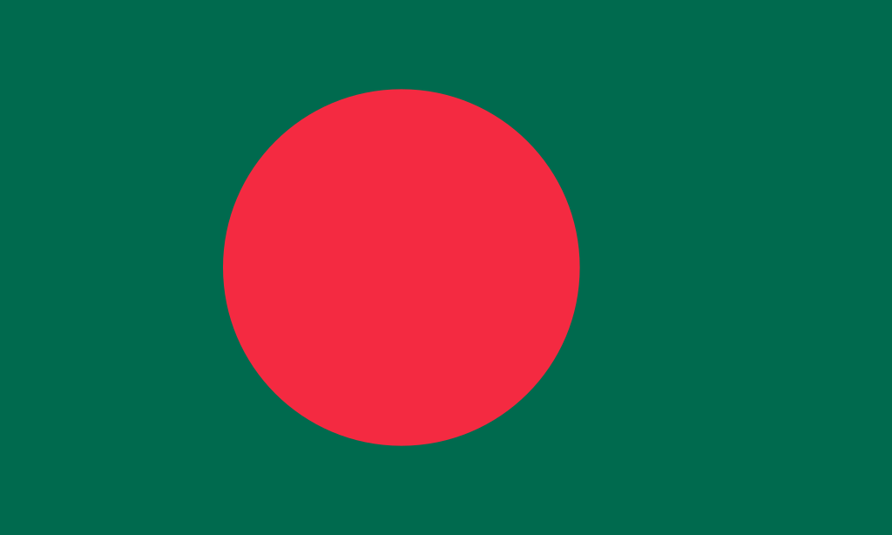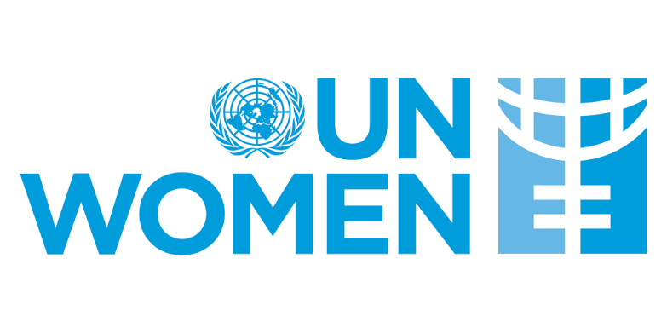**Agenda Item:** Women’s medical negligence

Founded in 1971 as a secular people’s republic, Bangladesh is the most densely populated country in the world, with a population of approximately 160 million people.

Bangladesh joined CEDAW in1984. The constitution recognizes equal rights for women and men in the public sphere, and there is a fairly strong legal and political framework that guarantees women’s rights. The National Women’s Development Policy 2011 and the National Action Plan provide a basis for government action to promote gender equality, and the 7th 5-year plan integrates gender equality issues across a range of sectors with some new sectoral policies that effectively address gender issues.

The country is internationally recognized for its good progress in a number of gender indicators. These included gender equality in primary and secondary education and declining female mortality over the past few decades, estimated at 5.5 percent each year. Bangladesh ranks highest in the Gender Gap Index in South Asia, ranking 47th out of 144 countries in the world2. However, significant gaps remain. Rates of violence against women remain high. Almost two out of every three married women in Bangladesh have experienced some form of intimate partner violence in their lifetime, and more than half have experienced it in the last 12 months. Discrimination against women continues in family life. In Bangladesh, marriage, divorce, child custody, alimony, and inheritance are all governed by religious law, and these "personal laws" often discriminate against women.

Bangladesh has a significant history of women organizing movements to demand their rights. Over the years, women's groups have mobilized themselves and made their voices heard on a variety of issues, starting with violence against women, gender equality in securing economic opportunities and participation, equal representation in politics, reproductive rights, family law reforms, and gender mainstreaming in public policies.

In this context, UN Women in Bangladesh is working with government and civil society partners in the following areas:

* Income security, decent work and economic autonomy for women
* Women live a life free of violence
* Governance, national planning and budgeting for gender equality
* Women and girls equally contribute to and benefit from sustainable peace and resilience, the prevention of natural disasters and conflicts, and humanitarian action