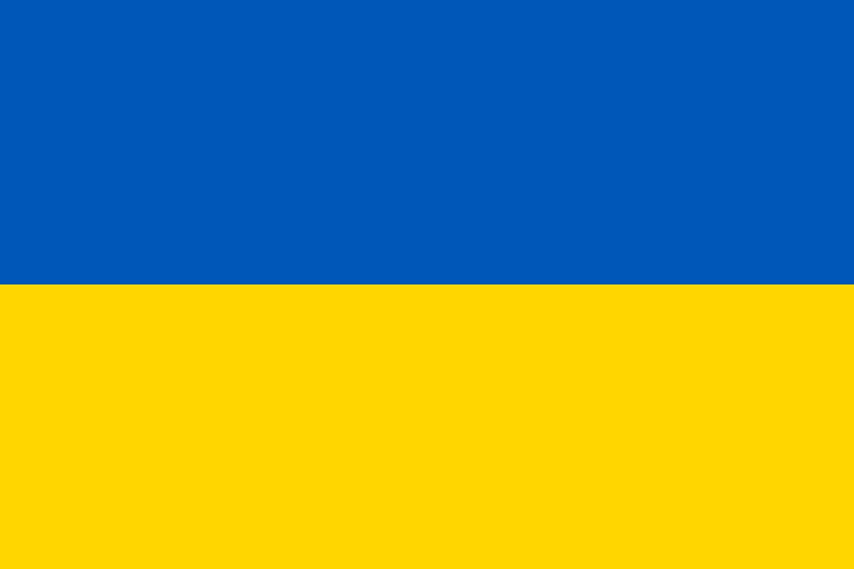

**Committee: Disarmament and Security Council (DISEC)**

**Country: Ukraine**

**Agenda item: Proliferation of Nuclear Weapons in Russo Ukrainian war**

The Russo-Ukrainian war’s signs first emerged in February 2014 with the Crimea conflict caused by Russian Federation’ military interventions, by annexing Crimea. This actions were widely condemned around the world, including UN General Assembly, which declared the move as a unlawful action. Conflicts in the area continued with the pro-Russian separatists in the Eastern regions of Donetsk and Luhansk declaring independence from Ukraine, igniting a war in Donbass region which has caused over 13,000 deaths and 30,000 injuries. Russian Federation has been implicated in providing substantial military support to these separatists, a factor which has intensified and prolonged the conflict. First invasion of Ukraine, our country, began in 24 February 2024 with Vladimir Putin announcing a "special military operation" to demilitarize and degasify the area.

Nuclear weapons have been a threat to modern society since their invention in 1945. Unfortunately, the world had to witness its disastrous consequences in Japan, twice. The horrors of mass destruction weapons and nuclear bombs are not only in their immense capability to wipe out a city in the blink of an eye but also, due to their fallout which trashes the area it exploded on, for centuries. Right now the world is facing this threat again with the use of more sophisticated, advanced weapons in the present war increasing day by day.

Today use of nuclear warheads are prohibited by NPT (The Treaty on the Non-Proliferation of Nuclear Weapons. As Ukraine, the main victim of this war (alongside with the most of the Europe receiving economic damages caused by the energy crisis created by the Russia’s embargo of gas) we strictly stand with this agreement and fully support the further enforcement of it whether by force or diplomacy. Due to the reason that this is not only a conflict that concerns us but a one that threatens the future of the whole Europe.

Lastly we want to further clarify that we do not want or urge this war. It is only a defending matter for us. As any state that cares for their country or citizens would, we want this war to come to an end as soon as possible. Our sole aim at the present moment is to ensure the leaving of Russia and any other invasive forces from Ukrainian soil, whether by further military action or peacefully with diplomacy, as we would please.