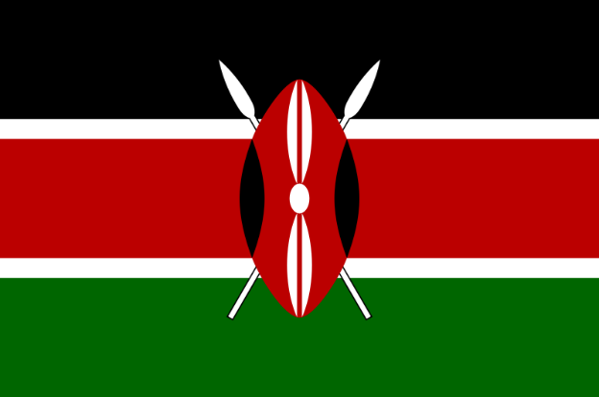Country: Kenya

Committee: UNWOMEN

Agenda Item: Women’s medical negligence

Delegate: Melis KARA

POSITION PAPER

Around the globe, women neglect their health for many different reasons, like lack of universal healthcare, economic problems and social barriers. When we put these issues in the mix, the problem becomes something that cannot only be explained by negligence. This issue is one also occurs in Kenya, and we aim to fix some of these problems with our planned for 2030 universal healthcare program.

**1. Women Rights in Kenya**

In Kenya, medical negligence is a serious concern, particularly when it comes to women’s healthcare. The government has recognized the need to address the issue and has taken steps to improve the quality of healthcare services.

Compared to the past, gender equality in Kenya increases on a positive pace. After the second half of 2000’s, our Women’s Business and Law index score increased exponentially from 51.9% to 80.6% as of 2022. These data are indicators of the increasing importance given to women's rights in Kenya.

**2.** **Problems Kenyan Women Face While Accessing Medical Care**

Women in East Africa countries, such as Kenya, have poor access to maternal healthcare. Even though it is legally possible for Kenyan women, there are social and economic barriers that prevent women of Kenya to seek medical care. Distance to health facilities is one of the reasons women in Kenya do not get immediate healthcare. Economics is also part of the issue, as many women in Kenya simply cannot afford medical care.

**3. The Worldwide Impact of Gender Inequality in Access to Healthcare**

Gender inequalities and gender norms intersect with socioeconomic, geographic and cultural factors and create structural barriers when accessing healthcare. Around the world, millions of women at all stages of life are unable to access the healthcare, treatment and support they need. This “women’s health gap” equates to 75 million years of life lost due to poor health or early death each year. Due to various obstacles such as financial barriers, women cannot access the medical opportunities they need and may be oppressed by society. Considering that women make up half of the population, a lack of financial investment in medical research into women’s reproductive and maternal health is also an issue.