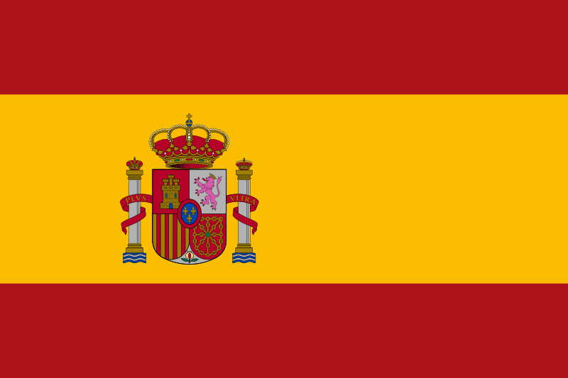

Country: Spain

Committee: UNWOMEN

Agenda Item: Women’s medical negligence

Delegate: Ali Emre BAŞARIR

POSITION PAPER

1. Women’s Rights in Spain

Throughout the years we trying to improve gender equality in every field possible.

Over the years, we have taken significant steps in women's rights such as Violence Against Women Equal Pay and Employment Political Representation. Since 1978, we guarantee equality before the law regardless of gender and we allow women access to reproductive healthcare services, including contraception and abortion.

2. Problems Spanish Women Come Across In Medical Field

In the medical field in Spain, as in many other countries, women may face variety of challenges and issues. for example women in the medical field may encounter gender bias and stereotypes that affect their career advancement opportunities

Women in the medical field may experience harassment or discrimination based on their gender, whether from colleagues, supervisors, or patients. Creating a culture of respect and zero tolerance for harassment and discrimination is essential for ensuring a safe and inclusive work environment.

3. Our Goals For The Future

As spain we always thought about being one step further than the other countries and we are trying to provide equality in everything especially in medical health. To ensure the medical welfare of women, we will make cottage hospital  all around our country to ease medical concerns.