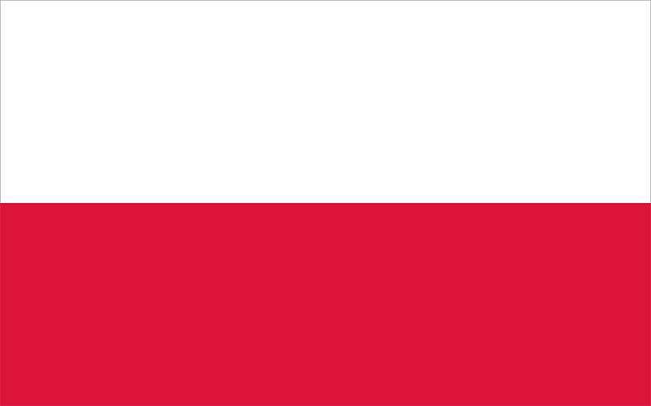Country: Poland

Committee: DISEC

Agenda Item: Proliferation of Nuclear Weapons in Russo-Ukranian War

Delegate: Bade Say

POSITION PAPER

Destruction nuclear weapons brings it is an undeniable fact. As Poland, we do not want our citizens to live in the danger of a nuclear fallout and our stance in on nuclear weapons are clear. During the early stages of Russo-Ukranian war, the talks of using nuclear weapons was a serious question. Our intention is to ease the tension of both sides through diplomatic means.

1. Poland's Stance on Nuclear Weapons

We are determined to prevent the proliferation of nuclear weapons and to safeguard international peace and security as Poland. We are actively engaged in efforts to prevent the proliferation of nuclear weapons and achieve disarmament goals.

Formun Üstü

We are acting in accordance with the objectives of the Treaty on the Non-Proliferation of Nuclear Weapons (NPT) and collaborating with the international community for its effective implementation. We support NATO's efforts to prevent the proliferation of nuclear weapons and maintain international peace, and we work with our allies. As Poland, we are determined to strengthen international efforts to prevent the proliferation of nuclear weapons and to continue our contributions towards global security and stability.

2. Poland's Stance on Russia-Ukraine War

As Poland, we strongly condemn Russia's aggressive actions towards Ukraine. We support Ukraine's right to preserve its territorial integrity and sovereignty, and we strongly oppose Russia's actions that violate international law. As Poland, we continue to enhance Ukraine's defense capabilities alongside our NATO allies. Additionally, we support the assistance provided by the European Union to Ukraine and endorse sanctions against Russia. We stand firmly against Russia's aggressive policies towards Ukraine and are steadfast in our commitment to addressing this issue with equal determination within the international community. We continue to strive for unity and concerted efforts on this matter.

3. Solutions to Prevent Nuclear Warfare

Prevention of nuclear warfare is achievable through collective efforts of the international community. No country would benefit from a nuclear attack on either side. As Poland, we aim to avoid this disaster by diplomacy with our allies and expect every other country to follow the same principles.