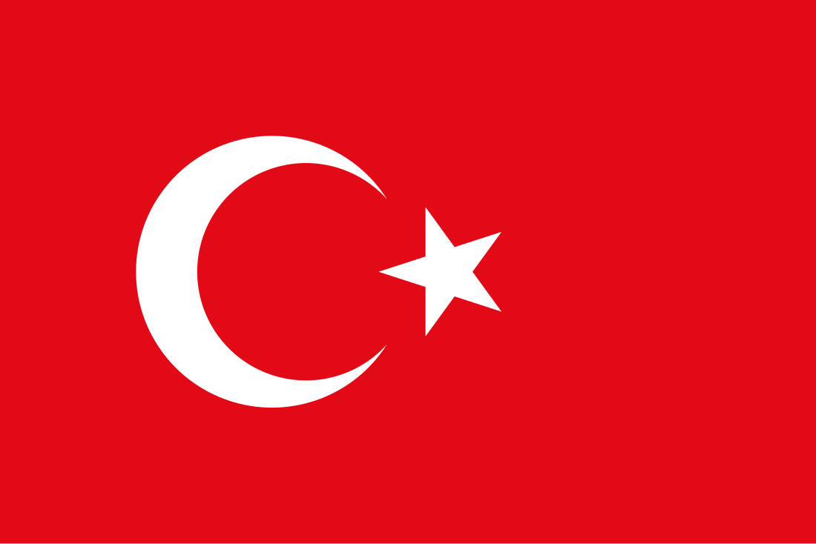**Republic of Türkiye**

**North Atlantic Treaty Organization (NATO)**

**Ratification of Sweden’s NATO Membership in Fostering Cooperation and Partnership between Partner States.**

**Tackling the Risk of Foreign Information Manipulation and Interference Amid Russia's Invasion of Ukraine.**

Türkiye has been a strong NATO ally since 1952 when it joined NATO, Türkiye has been committed to preventing the expansion of communism and Russia. Türkiye understands the geopolitical importance of Sweden when it comes to expanding NATO’s safety scope in Europe and what the country brings to the table when it comes to mutually assured defense. However, Türkiye would also like for the alliance to recognize that Sweden has been harboring the Kurdistan Workers’ Party (PKK) and its affiliates in Sweden, which Türkiye and its allies consider a major international security threat and a terrorist organization. Türkiye has also recognized the religious attacks against the nation when an anti-immigrant politician from the far-right burned a copy of the Quran near the Turkish Embassy in Stockholm. Türkiye condemns Sweden for allowing such action. While Türkiye doesn’t oppose Sweden’s accession into NATO Türkiye would like strong and clear guarantees and commitments to strengthen counterterrorism cooperation specifically the Kurdistan Workers’s Party. Türkiye fully supports NATO’s efforts to go against foreign information and manipulation, understanding its threat to its members. Russia’s hybrid warfare strategy since 2024 in Ukraine (Including but not limited to Türkiye) includes Russian propaganda which is recognized by the Turkish government to have the potential to destabilize not only Ukraine but also NATO allies and partners.

                Türkiye has played a major role in the decision of Sweden’s NATO membership, particularly reasoning the security concerns related to terrorism Türkiye has initially blocked Sweden’s application due to Sweden harboring Kurdistans Worker’s Party and its affiliates, signed a trilateral memorandum at the NATO summit in Madrid in 2022 with Sweden and Finland to address Türkiye’s concerns. The agreement outlined several commitments which include but are not limited to Sweden and Finland agreeing to intensify their counterterrorism cooperation with Türkiye and Sweden pledging to modify its laws and regulations to meet Türkiye’s demands, particularly in anti-terrorism and both countries promised not to support the Syrian Kurdish militia which Türkiye links to the PKK. Despite the memorandum, Türkiye continued to delay ratifying Sweden’s membership, stating Sweden needed more substantial progress in implementing its commitments. This led to additional rounds of diplomatic meetings between the two states. Türkiye has taken major steps to address the issue of foreign intelligence manipulation, more in the context of Russia’s invasion of Ukraine. However, Türkiye’s approach has been complex due to Türkiye’s balancing act between Russia and NATO. Türkiye has passed a “Disinformation Law” to limit the spread of false information especially on social media platforms. The law allows the prosecution of individuals and entities that spread false information. Türkiye has sought to maintain a pragmatic relationship with Russia to not elevate the conflict and keep mediation opportunities on the table with Russia and NATO. Türkiye has provided humanitarian aid and diplomatic support to Ukraine and played a role in brokering the Black Sea Grain initiative raised by Russia and Ukraine. Türkiye hasn’t and will not in the foreseeable future match NATO’s sanctions to Russia. Türkiye has also set up the “Siber Ay” project to expand cybersecurity capabilities training alongside NATO’s cyber defense programs and participates in NATO's exercises like the Cyber Coalition.