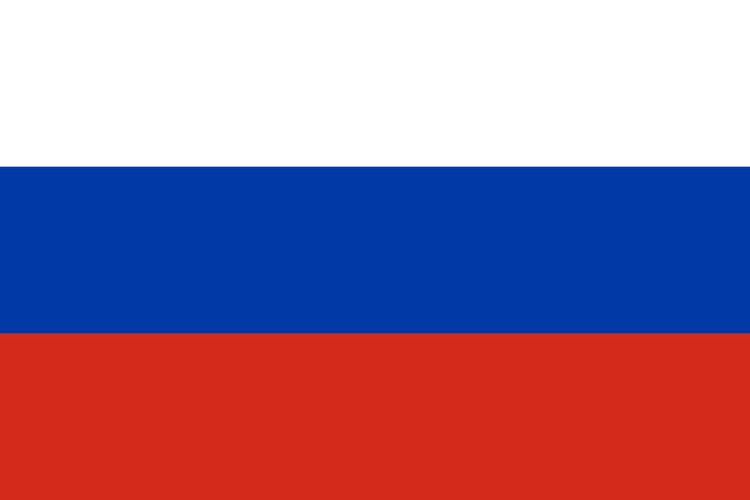

Country: Russian Federation

Committee: Social, Cultural & Humanitarian Committee (SOCHUM)

Agenda Item: Freedom of Press

Russia is a country stated on a huge area containing Asia and Northern Europe. Moscow is the capital of the country. It is the world’s ninth most populated country, being the most populated country in Europe. The constitution in 1993 declares Russia is a democratic, federative, law-based state with a republican form of government.

Freedom of press has been a crucial issue around the globe for many years. Freedom of information and freedom of expression are the two of human rights. Freedom of information highlights the importance of giving information briefly. Information given to people lead socities in many ways. This is way it is important to deliver information as true as possible. On the other hand, freedom of expression focuses on individuals expressing themselves freely. If an individual is under pressure, both of these rights get violated. In order to prevent violation against rights, Sustainable Development Goals have been discussed. These goals aim to protect the planet and end poverty by 2030, resulting all people enjoy peace. There is also an international non-profit organization called Reporter Wtihout Borders, which stand up for the right of everyone having access to reliable information. However, there are threats to press freedom. Legal threats are defamation and insult, Stretegic Lawsuits Against Public Participation (SLAAPs), fake news, counter terrorism and anti-extremism laws and many more. Illegal threats are kidnapping, harresment, violence, disappearences.

In order to solve these issues and provide a free and less pressured atmosphere for individuals, countries have come up with many solutions. Raising awareness among individuals and educating the public on independent journalism is crucial. Moreover, cooperating with non-govermenatl organizations and institutions may help approaching more people. As Russian Federation, we state that censorship plays a crucial role. Censorship should be controlled by the government on any type of content, such as series, boks, newspapers, television.

Bibliography;

<https://www.globalgoals.org/goals/16-peace-justice-and-strong-institutions/>

<https://rsf.org/en>