Commitee: Disarmament and International Security Commitee  Agenda Item: The Regulation of Chemical Weapon Possesion and Usage  Country: Russian Federation  Delegate: Defne Karagöz | 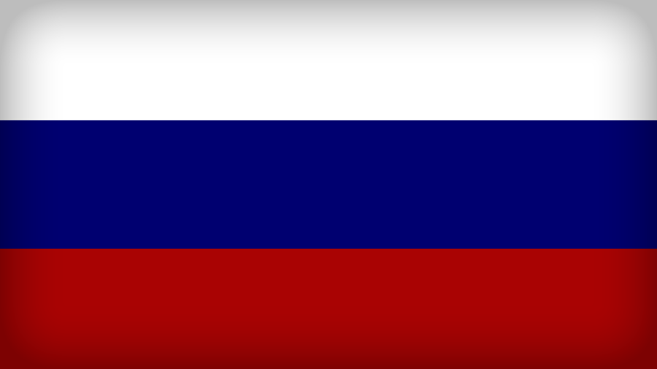

As a responsible country of Disarmament and International Security Commitee (DISEC), Russian Federation always attaches credence to tranquility in the world. We believe that chemical weapon usage must be restricted since they are extremely destructive and fatal.
Russian Federation highly concerns about international and national safety; therefore, the relevant country must have the ability to protect any group which may create a chaotic environment in the country. However, some cases might need any kind of extra sources for solving the issue. As Russian Federation, we are obliged to interfere with prohibition of nuclear weapons, and we strongly believe having a cooperation with other countries will solve current problems easily.
Russian Federation acknowledges of the fact that we should nullify all of the chemical weapons which can be a dangerous through the public, environment or the relevant country. As a member country of the United Nations, we believe that collaboration among countries with the highest transparency is the only way to restrict chemical weapons and consequently stop its destructive and harmful effects on the environment. Russian Federation is being acquainted with the fact that has a critical role in DISEC and will try to make the best connections with other countries in order to find solutions for the ongoing problems in the world.
As Russian Federation we highly believe that all UN members should take precautions to usage of all kinds of chemical weapons by conceivable political agreements which would be very useful in the times of crises. These agreements must be on controlling chemical weapon usage and trying to make a better situation. However, Russian Federation is highly against the idea of controlling domestic affairs because of the fact that DISEC can only give suggestions to the United Nations Security Council (UNSC) in order to make a preferable communication environment. We believe that trying to control the domestic affairs will only create more aggressive position for both sides.
Russian Federation is looking forward to creating the best environment for peace, and respect. We believe that every agreement must have advantages for both sides to create the equableness environment in the relevant countries. Russian Federation is willing to sign an agreement which is commensurably conducted.
Russian Federation’s agreement policies are strictly stake out from the home affairs in the country due to past under designed concordats. While there are ongoing wars in the middle east, which the relevant country caught off guard while using white phosphorus which is against the international laws. While these events are going on today's world like as every other country, Russian Federation is taking actions to provide the national security.
As Russian Federation, we are highly against the idea of stocking up the chemical weapons, and as it was mentioned before, since chemical weapons are extremely fatal and harmful, we reject the idea of using it safely which wouldn’t be affirmable. We need to highlight the fact that if Russian Federation encounters with an extremity critical situation, we will be bound to the policy of prohibition ourselves.

