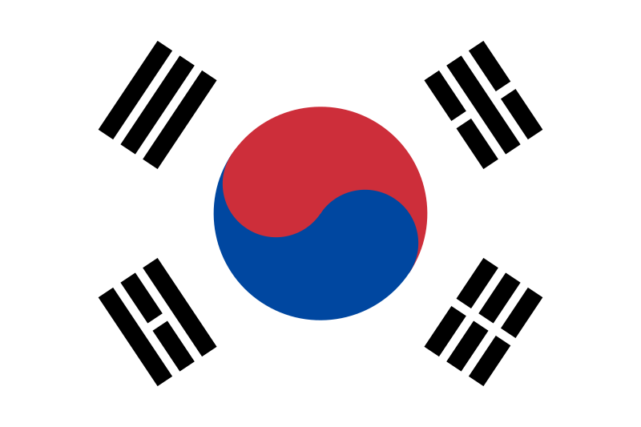

**Confrence:**HUMUN ‘24

**Committee:**UNDP

**Topics:** Agenda Item A: Quality Education Interruptions Due to Territorial Disputes in the Middle Eastern and North African (MENA) Region

Agenda Item B: Development of Nuclear Energy and Its Effects on Environmental Matters

**Country:**Republic of Korea

**Delegation:**Mehmet Emin Resulzade Anatolian High School

**Agenda Item A: Quality Education Interruptions Due to Territorial Disputes in the Middle Eastern and North African (MENA) Region**

Every person has the right to have proper education without any discrimination and states should take all appropriate measures to ensure that school discipline is administered in a manner consistent with the child’s human dignity. However in the Middle Eastern and North African (MENA) Region children are facing severe difficulties about this topic. This area has been the center of the most brutal battles throughout history. Unfortunately MENA is still experiencing challenges due to territorial disputes. One of the biggest issue is the destruction that comes with conflicts. Children lose their right to education because conflicts leave an environment that harms the quality of education. And this leads to more terrorist acts happening since low quality education leads to the lack of socioeconomic, political and demographic conditions.

Republic of Korea is fully aware of the possible challenges and its impacts on children. Republic of Korea is in many alliances with the states of Middle Eastern and North African Region. We are highly concerned by these horrible circumstances. Education is one of the most significant human rights because it sets the ground for childrens future which is why Republic of Korea is ready for international cooperations that will solve these problems.

Even though Republic of Korea is not a member state to the Middle Eastern and North African Region it believes that no children should be educated with low quality because in long term it may cause an international problem which is why this issue should be seen as an international challenge. Republic of Korea is fully alarmed by this problem and is ready to collaborate with other countries.

**Agenda Item B: Development of Nuclear Energy and Its Effects on Environmental Matters**

Nuclear energy is the energy type that is produced by the splitting of the atom with the help of

reactors. Nuclear energy is not a renewable energy source but among the non-renewable energy

sources it is the most stable source of energy because the reactors that are needed to produce

nuclear energy are low-carbon emitting. However because that it is not renewable nuclear

energy’s waste can not be used again and is very dangerous if not handled properly. One other

challenge about nuclear energy is the expensiveness. Producing the nuclear energy is expensive

enough but the cost of handling the waste properly is even more expensive.

Republic of Korea is one of the countries with the most nuclear energy reactors which makes it

one of the countries with the most nuclear power. Nuclear power is a significant power source

considering it provides 29% of the country’s electricity. Because that it is one of the main energy

sources, difficulties about nuclear energy is very important to the Republic of Korea. On the other hand the government wants to keep using this energy source due to its low-carbon emission.

Nevertheless Republic of Korea is fully aware that nuclear energy may cause some

environmental problems because of its non-renewable waste even so we believe that these

problems can be solved with proper handling of the waste and that nuclear energy should still be

a reliable source of energy.

BIBLIOGRAPHY

*Nuclear Power in South Korea | Nuclear Energy in the Republic of Korea - World Nuclear Association*. (n.d.). World Nuclear Association - World Nuclear Association. <https://world-nuclear.org/information-library/country-profiles/countries-o-s/south-korea.aspx#:~:text=Nuclear%20energy%20has%20been%20a,30%%20of%20electricity%20in%202030.>

*Advantages and Challenges of Nuclear Energy*. (n.d.). Energy.gov. <https://www.energy.gov/ne/articles/advantages-and-challenges-nuclear-energy>

*What is Nuclear Energy? The Science of Nuclear Power*. (n.d.). International Atomic Energy Agency | Atoms for Peace and Development. [https://www.iaea.org/newscenter/news/what-is-nuclear-energy-the-science-of-nuclear-power#:~:text=Nuclear%20energy%20is%20a%20form,fusion%20–%20when%20nuclei%20fuse%20together.](https://www.iaea.org/newscenter/news/what-is-nuclear-energy-the-science-of-nuclear-power#:~:text=Nuclear%20energy%20is%20a%20form,fusion%20%E2%80%93%20when%20nuclei%20fuse%20together.)

*Nuclear Power in South Korea | Nuclear Energy in the Republic of Korea - World Nuclear Association*. (n.d.). World Nuclear Association - World Nuclear Association. <https://world-nuclear.org/information-library/country-profiles/countries-o-s/south-korea.aspx#:~:text=Nuclear%20energy%20has%20been%20a,30%%20of%20electricity%20in%202030.>

*South Korea*. (n.d.). Asia Society. <https://asiasociety.org/asias-new-pivot/south-korea#conclusion>

(n.d.). <https://www.cypcs.org.uk/rights/uncrc/articles/article-28/#:~:text=Article%2028%20of%20the%20UNCRC,if%20they're%20a%20refugee.>

*Convention on the Rights of the Child*. (n.d.). Right to Education Initiative. <https://www.right-to-education.org/resource/convention-rights-child>