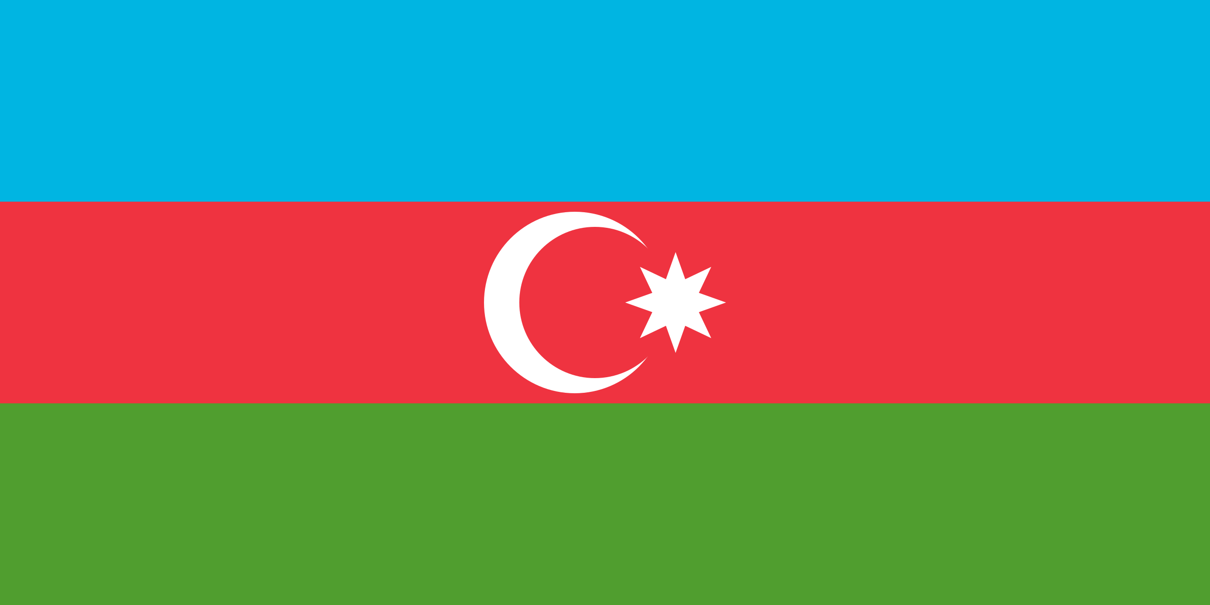
POSITION PAPER
Conference: Hacettepe University MUN
Committee: UNWOMEN
Agenda: 1) Women on Governance and National Planning 2) Promoting Gender Equality in the Digital Age
Country: Azerbaijan
Delegate: İpek Canalp
- Topic Background
Women empowerment is part of the Sustainable Development Goals and as Azerbaijan we
are working towards their achievement. However, challenges exist that hinder the attainment
of gender equality in high-level positions in government. Such challenges are the stereotypes
related to the role of women in the community and women’s uncertain self-confidence and
interest. We are working ambitiously towards our achievement with only a small percentage
of women that occupy high-level government positions in our Administration. The gender gap
between men and women makes it hard to create an equal environment for both genders. The
gap depends on political, economic, and social life in our country. For instance, the lack of
belief and interest of women in their power and development potential, or the prevalent
negative and prejudiced stereotype images entrenched in society that affect women’s education
prospects. These factors play a crucial role in women’s prospects of advancing to high-level
positions in the Administration of Azerbaijan.
The Internet has a meaning of accessing information on an equal basis for all, but gaps also
remain in the digital space, whether gender, social, or cultural. In the situation of our country,
women are actively involved in the development of the information society and the digital
economy. These women are active users of Information Technology (IT), but they rarely act
as producers. Men still hold the majority and occupy the highest positions in the technology
sector. We believe that by gaining access to IT, women will have more opportunities to
express their views in society, government, and globally.
- Past Actions and Country’s Policy
In overcoming gender equality-related challenges that mostly occur from post-Soviet legacy
and the male-dominated culture of Islam, we have attempted to implement many initiatives.
For implementing a gender policy in the Republic, by decree of the President, on 14 January
1998, the State Committee on Women's Problems (SCWP) was created to foster the
enhancement of the role of women in the political, social, economic, and cultural life of the
country.
Beginning in 1998, in the Republic, there has been a tendency to strengthen the role of
women in society. In the Parliament of Azerbaijan -Milli Mejlis-there are 13 women deputies
(10.4%), who actively participate in the work of drawing up legislation, creating the legal
conditions for real equality between the sexes, and securing the individual freedoms of
women.
On 2 July 2000, a duly authorized official for human rights was elected. From three
candidates put forward by the President, the Milli Mejlis (Parliament) by a majority vote
elected a woman for this high position. Since 2000, the Office for Democratic Institutions and
Human Rights of the Organization for Security and Cooperation in Europe has been
implementing a project on women's leadership and their participation in decision-making,
and, in this project, workers of the SCWP have actively participated.
In recent years, gender equality in the digital economy has also been highlighted as an
important factor. Special attention is paid to it in our country as well, with women playing an
important role in IT. Women now account for 29.7% of the 26,500 employees working in the
field. We have special platforms for women. The Girls Code platform is an example of this.
This aims to ensure women’s active participation in the IT sector, building successful careers,
reducing gender inequality in the IT sector, and further increasing the number of women in
this field. Currently, more than 1,000 women are members of this platform, which has held
several trainings and awareness-raising events. The ICT LAB Application and Education
Centre in Azerbaijan has implemented a project called “Digital
Girls”, a national education programme with the assistance of UNESCO. As part of the
project, 560 students and young girls were trained in digital skills and computer technology,
personal development skills, and ways to achieve success using these skills. These girls also
learned about the possibilities of building a successful career in the ICT field.
We believe that bridging the gender gap in the learning, teaching, and practice of science,
technology, engineering, and mathematics (STEM) is vital to achieving the Sustainable
Development Goals and creating infrastructure, services, and solutions that work for all people.
With the partnership of UNDP and Azerbaijani Women in Science (AWIS) organization, a
project has been implemented. There have been mentoring sessions, webinars that involve 40
specialists covering the many aspects and benefits of STEM education. The project has
facilitated the creation of new internship and job opportunities for young women. This project
also included taking both men and women role models to rural regions of Azerbaijan to engage
directly with parents and encourage them to make support come from home.
- Solution Ideas
- Having workshop establishments that educate women and girls about technology and
the digital world.
- Maintaining more technology and communication capacity in rural areas.
- Having seminars by women in STEM fields to be role models to women and girls.
- Raising awareness about gender stereotypes.
- Reminding children from an early age that they are capable of incredible things and that intellectual abilities are not divided by gender.
- Making current conditions and existing stereotypes altered to allow women to occupy positions of power.
- Training women candidates in campaigning skills.
- Mobilizing a media campaign that encourages women’s political participation.
- Making the young generation informed about technology and media by educating them.

- Bibliography
Pavlowitch, K. (2020, November 2). Digital growth: working towards gender equality in IT in Azerbaijan. EU4Digital. https://eufordigital.eu/digital-growth-working-towards-gender-equality-in-it-in-azerbaijan/
#GirlsCan and we believe in you. (n.d.). UNICEF Azerbaijan. https://www.unicef.org/azerbaijan/stories/girlscan-and-we-believe-you#:~:text=In%201918%2C%20the%20newly%20formed,women%20the%20right%20to%20vote.&text=02%20November%202018-,In%201918%2C%20the%20newly%20formed%20Republic%20of%20Azerbaijan%20became%20one,women%20the%20right%20to%20vote.
Wikipedia contributors. (2024, February 5). Women in Azerbaijan. Wikipedia. https://en.wikipedia.org/wiki/Women_in_Azerbaijan#:~:text=Political%20representation,-The%20State%20Committee&text=There%20are%20no%20legal%20restrictions,percent%20between%202005%20and%202020.
More women and girls in Azerbaijan are getting involved in science. (n.d.). UNDP. https://www.undp.org/azerbaijan/blog/more-women-and-girls-azerbaijan-are-getting-involved-science#:~:text=involved%20in%20science-,More%20women%20and%20girls%20in%20Azerbaijan%20are%20getting%20involved%20in,female%20mentors%20and%20their%20mentees.
Vasechko, V. (2023, March 14). Who shapes the world? Women in STEM and future goals - EU NEIGHBOURS east. EU NEIGHBOURS East. https://euneighbourseast.eu/young-european-ambassadors/blog/who-shapes-the-world-women-in-stem-and-future-goals/
Political participation of women. (n.d.). UN Women – Asia-Pacific. https://asiapacific.unwomen.org/en/focus-areas/governance/political-participation-of-women
Hasonova, I., & Hasonova, S. (Directors). GENDER EQUALITY IN THE HIGH POSITIONS OF THE AZERBAIJANI GOVERNMENT [Film].

(2004). R E P O R T of the State Committee on Women's Problems of the Republic of Azerbaijan in response to a questionnaire for governments, relating to the implementation of the Beijing Platform for Action (1995) and the outcome documents of the 23rd special session of the General Assembly of the United Nations (2000) [Film].

