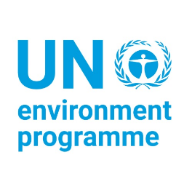 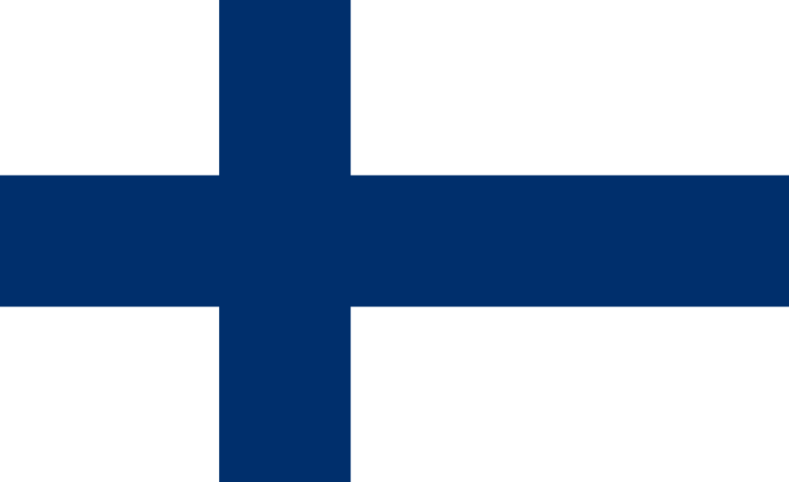 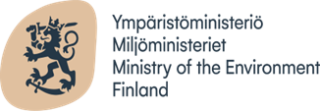

Country: Republic of Finland

Committee: United Nations Environmental Programme (UNEP)

Agenda: Assessing the Current State of the Climate Change Crisis

**About Finland**

The nation of Finland is located in northern Europe. Finland, which is geographically isolated and among the most northern countries in the world, experiences a severe climate. Finland serves as a symbolic northern border separating eastern and western Europe, characterised by thin forests and Russia to the east, and Sweden and the Gulf of Bothnia to the west. With dense woodlands covering nearly two-thirds of the territory, it is the most densely forested nation in Europe.

**Current situation**

We are facing the great problem of climate change at a critical point in history. Prioritizing sustainable development and making a strong commitment to aggressive climate action are essential. There is no denying that the Earth’s climate is changing, with rising temperatures being particularly noticeable in the Arctic. The annual average temperature in Finland has increased by about two degrees Celsius since the 1880s, while recent years have seen a breakthrough in rainfall records. Disruptions to ecosystems worsen the loss of biodiversity on a global scale, and the frequency of extreme weather events such as floods and droughts is increasing globally. Such effects are not limited to a geographical area; they also affect community resilience, economic stability, and global food production, all of which are present in Finland. These changing realities require industries like forestry, fishing, deer farming, and tourism to adjust. Because of this, Finns’ everyday lives are drastically changing as the summers become warmer and the winters become hotter.

**Actions by the UN**

The UN Environment Programme (UNEP) is in the center of the fight against climate change. It focuses on; encouraging the transition to low and zero carbon emissions in important areas like energy and transportation, collaborate with governments and the corporate sector to improve air quality and reduce emissions of short lived climate pollutant, protecting and rebuilding natural ecosystems such as forests and peatlands while dealing with the causes of degradation, empowering communities to create sturdy ecological foundations that will enable them to adapt to changing conditions, supporting public participation and behaviour change with international campaigns and educational initiatives.

**Finland’s National Climate Policy**

Finland’s Climate Act, which came into force on 1 July 2022, sets emission reduction targets for 2030 and 2050, with a goal of achieving carbon neutrality by 2035. The Act aims to reduce emissions by -60% by 2030, -80% by 2040, and -90% by 2050, with a target of -95% by 2050. It also includes a target for stronger carbon sinks in the land use sector. Negotiations with the Sámi Parliament are required for climate policy planning. The Act will be supplemented with an obligation for municipalities to create climate plans and provisions for requests for review. The Act’s impact is based on the climate policy planning system, with annual climate reports published to monitor targets and measures sufficiency.

**Possible Solutions**

In the battle against climate change,

1. concerted measures to cut emissions,
2. switch to renewable energy sources, and
3. protect the ecosystem

are critical to keeping our planet intact for future generations.

Net zero is an important goal in the fight against climate change. In order to minimise the most severe impacts of climate change, it is important that the global temperature rise be limited to 1.5°C above pre industrial levels, as stated in the Paris Agreement. To do this, we must drastically change the ways in which we produce, use, and move energy. Since the energy sector is mostly to blame for greenhouse gas emissions, fossil fuels must give way to renewable energy sources like solar and wind power. Setting strong standards and moving quickly to implement them are essential as more and more non state actors, including corporations, investors, cities, and regions, commit to net zero emissions

About 80 percent of the global population resides in countries reliant on fossil fuel imports, exposing them to geopolitical instability. Conversely, renewable energy presents a universal solution, yet to be fully tapped. Estimates by the International Renewable Energy Agency (IRENA) suggest that by 2050, 90 percent of global electricity could be renewable. With costs plummeting, renewables are increasingly competitive, offering a pathway to economic diversification and resilience, particularly for low- and middle-income nations. Cheaper renewable electricity could supply 65 percent of global demand by 2030 and decarbonize 90 percent of the power sector by 2050, significantly mitigating climate change. Moreover, transitioning to clean energy not only addresses climate concerns but also tackles air pollution, responsible for millions of avoidable deaths annually. Furthermore, investing in renewables generates three times more jobs than the fossil fuel industry and promises substantial economic savings. Despite the initial investment hurdles, transitioning to renewables offers long-term benefits in terms of economic, societal, and environmental well-being, provided that support mechanisms ensure a just transition for all communities.

**REFERENCES**

<https://www.un.org/en/climatechange/science/causes-effects-climate-change#:~:text=Generating%20power,and%20trap%20the%20sun's%20heat>.

<https://www.who.int/news-room/fact-sheets/detail/climate-change-and-health#:~:text=Climate%20change%20affects%20food%20availability,700%20000%20annually%2C%20may%20rise>.

<https://climatepromise.undp.org/?gad_source=1&gclid=CjwKCAjw17qvBhBrEiwA1rU9w_BgMkTlRmrXVIDyorfE8CknkNtnYmWvSqAVqYp0UjleskURHzXoGxoCIagQAvD_BwE>

<https://unfccc.int/kyoto_protocol>

<https://www.unep.org/explore-topics/oceans-seas/what-we-do/working-regional-seas/partners/world-wide-fund-nature-wwf#:~:text=The%20World%20Wide%20Fund%20for,spaces%20and%20addressing%20global%20threats>.

<https://www.britannica.com/place/Finland>

<https://www.unep.org/topics/climate-action>

<https://ym.fi/en/finland-s-national-climate-change-policy?__cf_chl_tk=wKCCmA2iM.1ArDv68FeYhzGbE_Zoofdl8AQrRZvG3OA-1710183587-0.0.1.1-1663>

<https://www.un.org/en/climatechange/raising-ambition/renewable-energy>