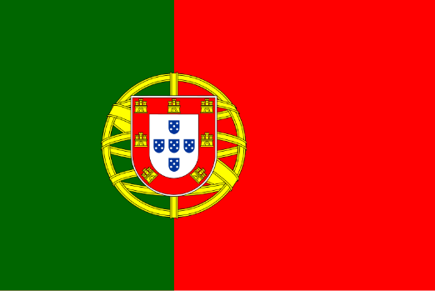COUNTRY:PORTUGAL

COMMITTEE:NATO

AGENDA ITEM 1:Ratification of Sweden’s NATO Membership İn Fostering Cooperation and Partnership between Partner States.

AGENDA ITEM 2:Tackling the Risk of Foreign Information

Manipulationand Interference Amid Russia’s Invasion of Ukraine.

Portugal supports Sweden’s NATO membership. NATO is a defense alliance that keeps Europe safe, and Sweden’s membership will make NATO stronger. Sweden has a modern army, and it shares our democratic values. This is very important for NATO. Sweden’s location in the north of Europe will also help us protect the Baltic Sea region.

Portugal believes that all NATO members must work together to protect peace in Europe. Sweden is ready to join, but it must also meet NATO’s defense spending requirements. We are confident that Sweden will reach the 2% target of its GDP for defense spending soon. Portugal welcomes Sweden as a strong partner in NATO.Portugal is deeply concerned about Russia’s invasion of Ukraine. This war is not only fought with weapons but also with misinformation and foreign interference. Russia uses false information to confuse people and make countries weak. This is very dangerous for NATO and all democratic nations.Portugal supports efforts to stop the spread of fake news and foreign manipulation. NATO countries must work together to protect their information systems.

We must share intelligence, improve cybersecurity, and educate our people to recognize fake information. Portugal is ready to cooperate with other NATO members to fight against this threat and defend truth and democracy.In conclusion, Portugal strongly supports Sweden joining NATO and stands firm against the dangers of misinformation during the Russia-Ukraine war. We believe that together, NATO will be stronger and more united to face these challenges.