Country: 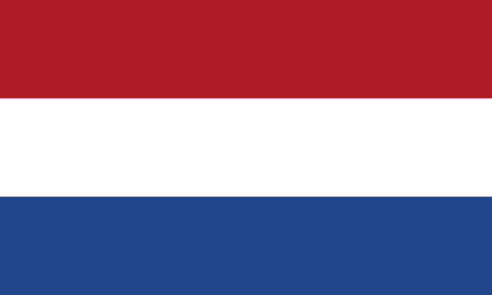 Kingdom of the Netherlands
Committee:
North Atlantic Treaty Organization (NATO)
Agenda Item 1:
Nuclear Deterrence and Energy Security
Agenda Item 2:
Enhancing Cohesion: Addressing the Military Duality Within the European Union

The Netherlands, also known as Holland, informally, is a constitutional monarchy with a parliamentary democracy which is in Western Europe sharing its borders with Belgium to the south and Germany to the east. The capital city of the Netherlands is Amsterdam, and the official language is Dutch. However, proficiency of English is widespread in the country. Netherlands means ‘low countries’ and it is not only the meaning of the word but also the reality of the country since its significant amount of territory is under sea level. Even though the long-term effect of this situation is against the country, The Netherlands has proved itself that the country is handling it well by having one of the richest agricultural and by experting in water management throughout the years. In the parliamentary democracy of the Netherlands, the prime minister serves as the head of the executive branch while the monarch serves as the head of state. The Dutch Parliament is made up of two chambers: the House of Representatives and the Senate. Overall, the political structure of the Netherlands integrates the democratic principles of representative democracy with the symbolic role of the royal family. Overall, while the symbolic role and historical value of the royal family is protected, the regime of democracy and its principles ensures the protection of rights.

The Kingdom of the Netherlands has been a prestigious member of the North Atlantic Treaty Organization since its establishment in 1949. Nuclear weapons and their deterrence have been an important topic for NATO as well as energy security. Due to that reason, The Netherlands protects NATO’s strategies in nuclear deterrence seeking prevention of aggression and guaranteeing member countries’ safety. Although not possessing any nuclear weapons of its own, the Netherlands developed relationships through nuclear sharing agreements with nations that possess, primarily the United States. The Netherlands promotes NATO's successful nuclear deterrence policy since it provides security to the alliance. The Netherlands understands and approves how substantial it is to vary the energy supplies to decrease the potential negative effects and improve developed energy resilience. Even though possessing large reserves of natural gas, the country has become dependent on energy imports due to rising energy supply consumption and a shift towards alternative energy sources. Diminishing the interdependency on importations is a must for the Netherlands, in that, renewable energy sources shall be prioritized.

The contributions of the Netherlands utilizing military equipment, aircraft, and vessels to NATO are incontrovertible. We are aware of the fact that it is the primary responsibility of the defense organization to protect our territory and defend the lands of other NATO members to be in harmony with the alliance. As Military dualism is crucial to address and maintain the current safe situation of NATO with the defence of Europe linked to it, both Transatlantic and European Union countries shall understand its vital importance. The Netherlands accepts the importance of NATO and its aim to remain the top priority for the member states while acknowledging the possible positive outcomes of a more powerful military structure in Europe. The country supports certain programs like the European Union Military Staff (EUMS), and European Security and Defense Policy (ESDP) to encourage cooperation and enhance the military power of Europe. The Netherlands targets to have a strategy that embraces strengthened transatlantic ties as well as Europe with a developed military capacity.

BIBLIOGRAPHY
Ministerie van Defensie. (2023, March 2). Military contribution to NATO. International Cooperation | Defensie.nl. https://english.defensie.nl/topics/international-cooperation/un-nato-and-eu/military-contribution-to-nato
Nato. (n.d.). Netherlands and NATO - 1949. NATO. https://www.nato.int/cps/en/natohq/declassified_162354.htm

