**Country:** United Kingdom 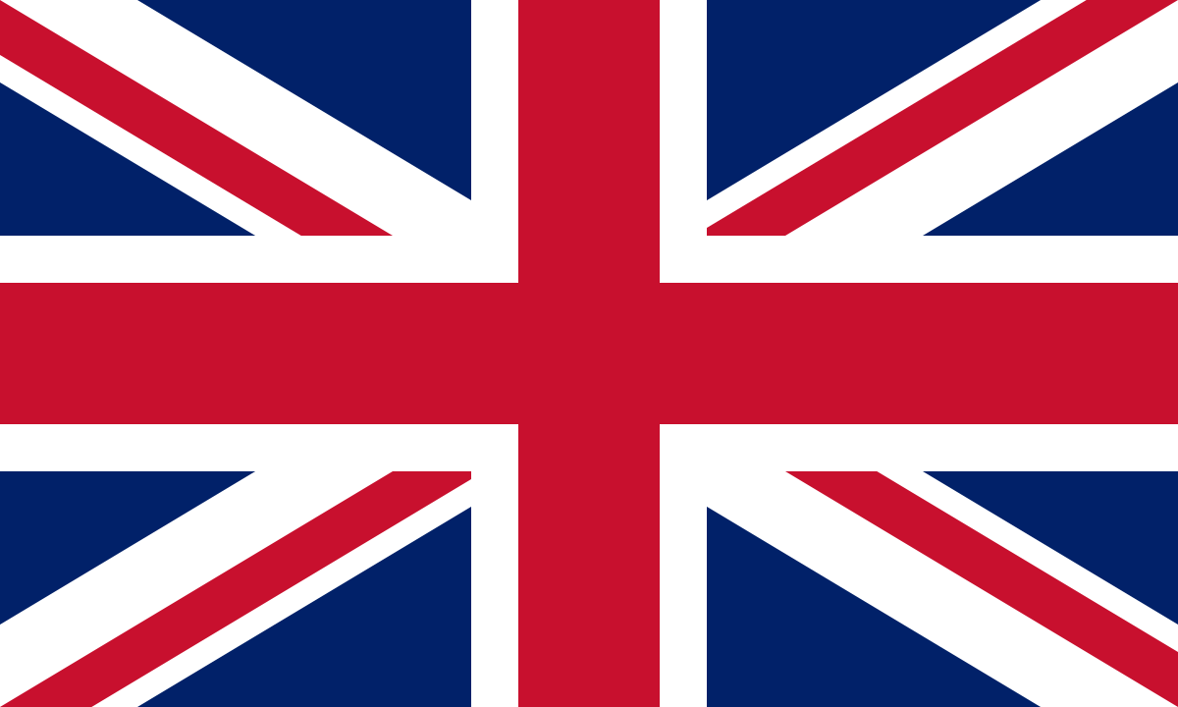

**Committee:**International Atomic Energy Agency(IAEA)

**Agenda Item:**Technology Infrastructure for Prevention, Detection and Responses Regarding Nuclear Security

The United Kingdom of Great Britain and Northern Ireland generally known as the United Kingdom or Britain. It’s a country in Northwestern Europe off the coast of the continental mainland. The country is low in the east. It has mountains in the north of England, Scotland, Northern Ireland and Wales. The current population of the country is 68,35 milion for now and that declares The United Kingdom is 18th most populous country in the world according to the Human Development Index. Also the economy of the United Kingdom is highly developed too. It is the 6th largest national economy in the world measured by nominal GDP. In the 18th century Brıtaın was the fırst nation to industrialize and was the beginner of Industrıal Evolution. The Government is led by the Prime Minister with the support of Cabinet and Ministers. The country is a member of the Commonwealth of Nations, Council of Europe, G7, OECD, NATO, Five Eyes, AUKUS and CPTPP.

**Agenda Item**: **Technology Infrastructure for Prevention, Detection and Responses Regarding Nuclear Security**

Nuclear energy and the usage of it had been debated dating back to the identification of nuclear fission in 1896. The United Kingdom remains commited to the ultimate goal of of a World without nuclear weapons and supports the full implementation of the Treaty on the Non Proliferation of Nuclear Weapons in all its aspects.The uk has a consistent and long track record on nuclear disarmement.We posses the smallest stockpile of nuclear warheads of the fivenuclear weapon states and are the only to have a reduced to a single delivery system.The UK believes that the only way to achieve a world without nuclear weapons is through gradual multilateral disarmament.

This can be best negotiated through the framework of the NPT, taking account of the wider global security situation. The NPT has played an unparalleled role in restraining the nuclear arms race and minimising the spread of nuclear weapons. It continues to make a significant contribution to international security and stability.We play a leading role by pioneering work on transparency,verification and irreversibility and work closelt with our international partners,çivil society and academia to reduce the risk of nuclear conflict and enhance mutual respect and trust within the member states. We consider the avoidance of war between Nuclear-Weapon States and the reduction of strategic risks as our foremost responsibilities.Our goal is to minimize green house emissions that increase the effects of climate change day by day by using nuclear energy safely while still maintaining our principles upon nuclear security and the power it holds.

From the United Kingdom’s perpective the UN(United Nations) could take the following potential actions:

Creating more freameworks and agreements so the transparency and intergity upon nuclear disarmament among member states will be kept

Encouraging developing countries who are positive about using nuclear power to collabrate and have partnerships with other member states

Enhancing physical and cybersecurity systems in power plant sources in order to obstruct catastrophic events from happening ever again

Creating independent organisations and commissions that can help who work on nuclear energy facilites by regularly checking their health

**References:**

https://www.gov.uk/government/publications/uk-nuclear-deterrence-factsheet/uk-nuclear-deterrence-what-you-need-to-know#nato-and-international-cooperation

<https://www.britannica.com/place/United-Kingdom>

https://commonslibrary.parliament.uk/research-briefings/cbp-9077/