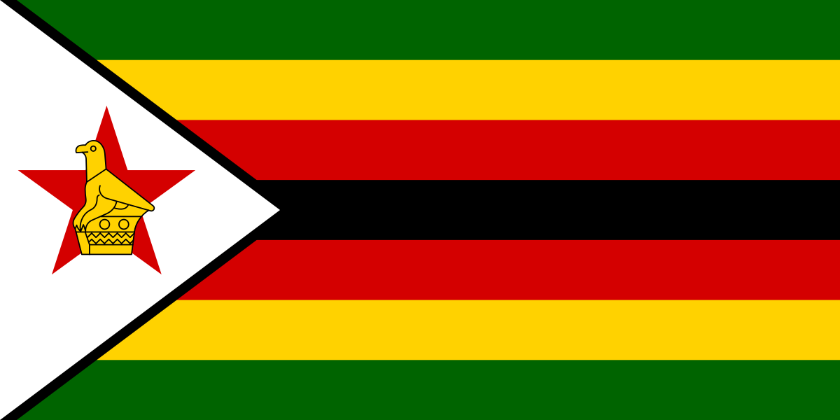

Country: Zimbabwe

Committee: DISEC

Agenda Item: The Regulation of Chemical Weapon Possession and Usage

The whole world has been scarred by many harmful decisions mankind has taken. One of these decisions are surely the development of chemical weapons and their active usage. As much as it can be seen as a modern problem, the history of chemical weapons goes far beyond the centuries. These chemical agents took action in many wars in history. These deadly weapons were used to incapacitate the opposing forces easily by not using as much human power as holding a gun and firing it requires. The first appearance of a chemical weapon was spotted in China in 1000 BC. When Chinese combatants used Arsenical smoke. Which was used to incapacitate their enemies. To contaminate water sources, Solon of Athens put hellebore roots in the drinking water of Kirrha in 600 BC. In AC times the first appearance of a chemical weapon is the “Greek Fire” which still has an unknown formula. This unknown formula enables the fire to float on water. In contrast, it is safe to state that chemical weapons are as old as when mankind has learned how to fight.

As the ambassador of peace, Zimbabwe has been scarred by these actions in the past too. The Rhodesian Bush War which took place in 1965-1980 concluded in the independence of Zimbabwe. While the war was in action Rhodesian colonial forces (which was considered to be one of the best military forces in Africa) used chemical agents against the guerilla forces of Zimbabwe (ZANU-PF and ZAPU-PF). The chemical agents that Rhodesian forces used against us were parathion (an organophosphate insecticide) and thallium (a heavy metal commonly found in rodenticide) which were mainly focused on incapacitating our men to not have supplies from other supporting external countries. Even the usage of chemical agents affected our forces the war has not been settled by any military victory. It was settled by the Lancaster House Agreement which proceeded in a fully democratic procedure of election we finally declared our independence on April 18, 1980.

Learning lessons from what has happened in the past we have taken actions to prevent any intervention of chemical agents in a war. We signed the CWC (Chemical Weapons Convention) on 13 January 1993 and then proceeded to ratify the convention on 25 April 1997. Being a member of the SADC (Southern African Development Community) we invariably aim for the advancement of our continent. Likewise, OPCW (Organisation for the Prohibition of Chemical Weapons) held the Africa Programme which aims to enhance the effectiveness of CWC we have shown participation in that programme in order to show our desire to raise awareness of how hazardous can chemical weapons become for the world.

Zimbabwe has benefitted immensely from these technical operations and deeply appreciates the co-hosts, co-organizers, and financiers of these activities. Zimbabwe fully appreciates the immense work done under the Africa Programme. Accordingly, we fully subscribe to the earlier statements made by our delegation which suggest the continuation of the Programme after 2016. For us, we think that the successor programme should be mostly focusing on the identified needs of member states and their demands. Likewise, it should be mentioned that some sub-regions in Africa have already carried out extensive consultations at sub-regional level. We suggest that the SADC sub-region be afforded the same opportunity to take stock of their burning issues. There is a need to have a well-accounted paper trail to enable us to trace abuses such as the recent contamination of water and fruit by the usage of cyanide. Likewise, to have more strict regulation and the accountment of chemical weapon stockpiles there should be a group of scientists called “Group of Accountability and Honesty” which focuses on accounting for the countries' stockpiles and making new regulations. This type of group is in need because of the countries' actions in the past. Such as postponing the destruction of their chemical weapons stockpile.

**REFERENCES**

Zimbabwe (OPCW)

<https://www.opcw.org/sites/default/files/documents/CSP/C-20/national_statemements/Zimbabwe.pdf>

Rhodesian Bush War 1960-85

<https://media.defense.gov/2023/Oct/23/2003326166/-1/-1/0/RhodesianBushWar_1965-80_20231204.PDF>

Africa Programme (OPCW)

<https://www.opcw.org/resources/capacity-building/international-cooperation-programmes/africa-programme>

Production, Stockpiling and Use of Chemical Weapons (UNTC)

<https://treaties.un.org/pages/ViewDetails.aspx?src=TREATY&mtdsg_no=XXVI-3&chapter=26>

The History of the Use of Bacteriological and Chemical Agents during Zimbabwe's Liberation War of 1965-80 by Rhodesian Forces

https://www.jstor.org/stable/3993569