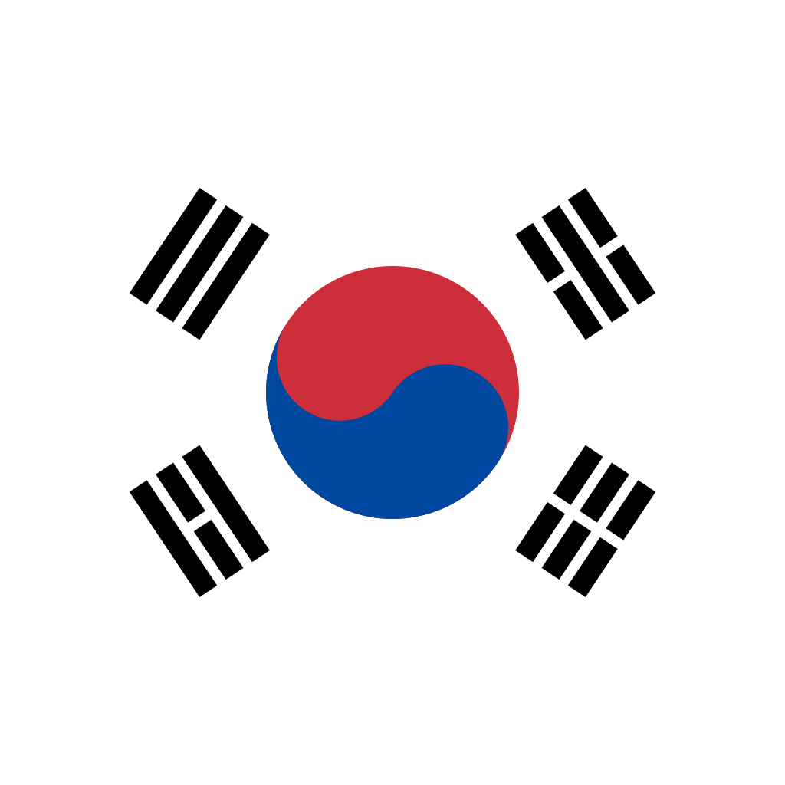 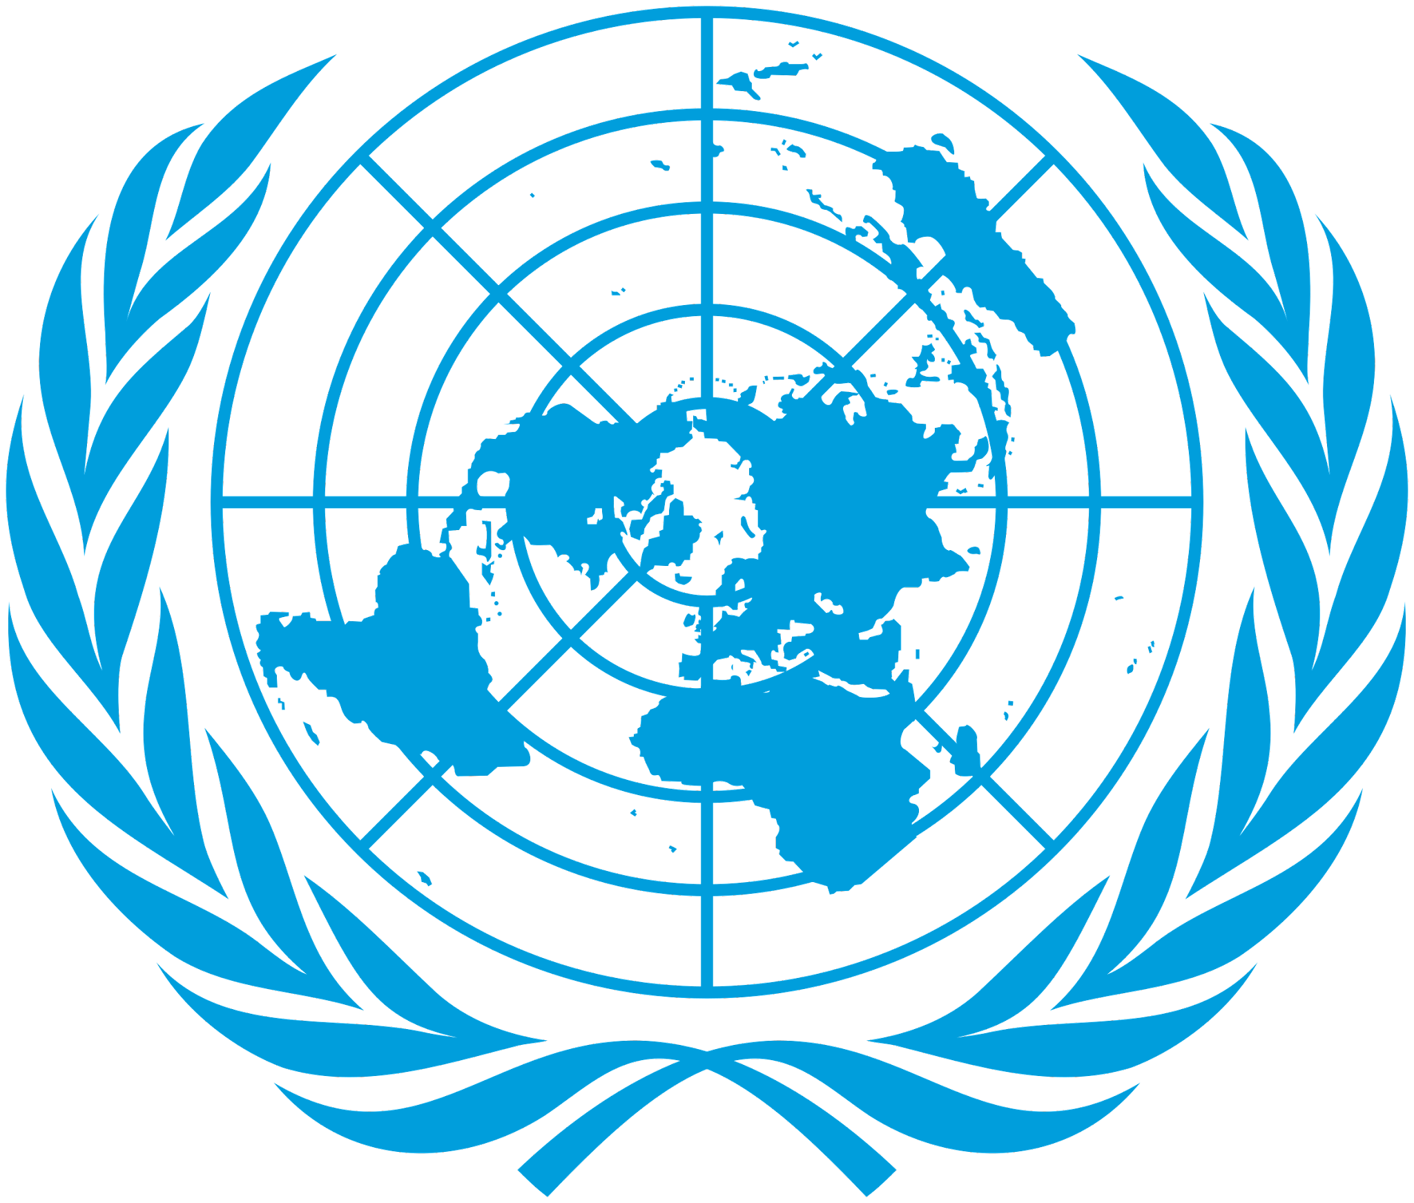

**Country:** South Korea

**Committee:** UNWomen

**Topic:** Women’s medical negligence

Women’s medical negligence is a pressing global issue that the world overlooks and requires immediate change. South Korea acknowledges the importance and significance of this issue and wants to take a step to bring a change to the world. All humans are obliged to medical care regardless of their gender, economic status, ethnicity, marital status etc. We have strict policies on equality of women set by the Ministry of Gender Equality and Family such as creating social infrastructure for work-life balance, enhancing women’s representation and participation, eradicating violence against women and improving women’s health, strengthening the implementation mechanism for gender equality policies and many more laws and policies ensuring the safety and equality of Korean women.

According to a study by the National Institutes of Health (NIH) it is observed that there is minimal gender discrimination towards women in the Korean medical community. The proportion of women doctors in Korea has increased from 12.4% in 1980 to 25.4% in 2017. It is expected to continue rising with the increase in women medical students where the proportion of women medical students was 36.0% in 2014. The quality of South Korean healthcare has been ranked as being among the world's best. We are known to promote female representation in medicine through initiatives such as scholarships and mentorship programs, promote equal opportunities for women in medicine including in career advancement, provide support networks for women who have faced challenges with medical providers, and recognize the sensitivity in gender equality in medicine and medical care with a special focus on eliminating discrimination towards women and young girls.

We as South Korea want to ensure no woman or child is deprived of their right to access the adequate medical care they require and no woman is detrimented from their right to be a part of the medical sector. We want to offer proper education and training to women and healthcare providers, more job and career opportunities where women will have equal rights, patient empowerment and advocacy, better access for healthcare services and medical care, reproductive care and maternal care, enforcing of laws that protect women’s rights and many more solutions that will ensure the equality among all and encourage women to raise their voice upon the unfairness that they experience because of their gender.

We as South Korea are in favour of ending this atrocious discrimination among all genders and are looking forward to finding solutions to promote gender equality among all nations.