Committee: GA1:DISEC 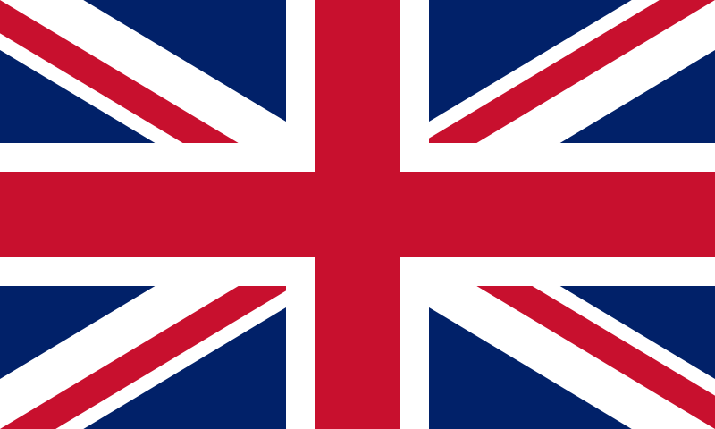

Country: United Kingdom Of Great Britain And Northern Ireland

Name of the delegate: Damla Uludağlı

School:Gazi Anadolu Lisesi

Agenda Item:

Impact of illegal arms trade routs to the Sahel region and the surrounding states

United Kingdom Of Great Britain And Nothern Ireland is also known as The United Kingdom(UK) to make it shorter. UK is a country that takes place in Northwestern Europe. UK is surrounded by the Atlantic Ocean, the North Sea, the English Channel, the Celtic Sea. UK takes a big area with 94,354 square miles. Currently the population of UK is nearly 68 million. London is the capital of UK. UK has a constitutional monarch with a parlimentary democracy which gives us some details about UK’s culture very specifically. UK is a member of United States and NATO(North Atlantic Treaty Organization). Also UK used to be a member of EU(European Union) nonetheless it is no more a member of it because of the Brexit.

Agenda Item (Impact of illegal arms trade routs to the Sahel region and the surrounding states)

The Impact of illegal arms trade routs to the Sahel region and the surrounding states is a living subject that should be concerned about. As the delegate of UK we are highly aware of this situation and it’s global harmful effects. If we need to clarify the issue, this situation really endangers the world security system by terrors and that kind of stuff that destroys the peace also we can not ignore the huge loopholes that it causes throughout the humanitarian situations. The importance of this issue doen’t ends here it also cause a bad reputation not only to Sahel region and the surrounding states but also to other countrys. It effects the economy negatively which shows us this is a problem that should not be underestimated. The precautions that has been made are clearly not enough so that we need to improve our precautions.

As the delegate of UK we believe that we could solve this problem by strict rules, education and the strenghten of institutionel capacity. By strict rules we could solve the authority problem and security problems to a point but it won’t be enough by itself. We firstly need to strenghten institutionel capacity for finding out the reasons behind this so that we could find permanent solution. Judging by the current issues about the security we believe that strenghten the security upon the national borders which could be possible by the education. Judging by the important of awareness we need to be carefull about the education since it is an important situation. The reason that we emphasize the education this much is because of it’s ability to make people bonds stronger which could at least lower the tension in public. Also without education we possiblly can not strenghten the institutionel capacity. So at last but not at least we believe that we need to solve the problem by the security system and the awareness of publicians. We need to strenghten the institutionel capacity for more information which could help to provide these other solutions.

Resources:

<https://en.wikipedia.org/wiki/United_Kingdom>

<https://news.un.org/en/story/2023/06/1137542>

<https://londonpolitica.com/africa-watch-blog-list/arms-trafficking-in-the-sahel>

<https://www.unodc.org/unodc/en/frontpage/2023/May/trafficking-in-the-sahel_-guns--gas--and-gold.html>

TEDMUN’24 GA:1 DISEC STUDY GUIDE