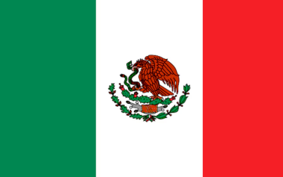

Country: Mexico

Committee: Food and Agriculture Organization (FAO)

Topic: Combating Food Insecurity and the Risk of Famine

The United Mexican States, commonly known as Mexico, is a federal republic in North America. It borders to the north with the United States; to the south and west with the Pacific Ocean; to the southeast with Guatemala, Belize, and the Caribbean Sea; and to the east with the Gulf of Mexico. Mexico is rich in natural resources, like oil, silver, copper, and agricultural products. Its economy boasts a rich diversity of agricultural crops, highly productive oil fields, a growing manufacturing base, as well as strong trade with the United States and Canada.

More people are going hungry, an annual study by the United Nations has found. The latest edition of the State of Food Security and Nutrition in the World, published today, estimates that almost 690 million people went hungry in 2019 - up by 10 million from 2018, and by nearly 60 million in five years. Mexico believes it is very important to help solve these problems. FAO has already started to help people who face challenges such as famine and global hunger. FAO’s some of the goals in Mexico are ending hunger, achieving food,

security, improving nutrition, and promoting sustainable agriculture.

Mexico suggests that the UN should focus more on supporting projects about conflicts, climate change, poverty, inequalities to access to resources and deforestation and soil erosion.

It is also important to empower people’s wealth and local farmers and decrease the inequalities among people. It is essential to offer assistance to these groups in order to enhance their means of living.