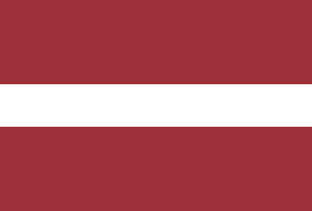Country: Latvia

Committee: European Council

Topic: The Refugee Problem in Europe

Latvia is a country in northeastern Europe, situated between Estonia and Lithuania. It was taken over by the Soviet Union in June 1940 but declared its independence on August 21, 1991. The USSR acknowledged its sovereignty on September 6, and shortly after that, Latvia became a member of the United Nations. In 2004, Latvia joined both NATO and the European Union. The capital and largest city of Latvia is Riga. Before the Soviet occupation in 1940, most people in Latvia were Latvian. Nowadays, Latvians make up about three-fifths of the population, while Russians are about one-fourth. There are also smaller groups like Belarusians, Ukrainians, Poles, Lithuanians, and others. Latvian is the official language, but almost a third of the population speaks Russian. Some people speak Romany, the language of the Roma (Gypsies), and Yiddish, a type of Germanic language.

The refugee crisis in Europe got much worse in the summer of 2015. While irregular immigration had always been a problem in European politics, the Syrian civil war made it much worse. It caused a big problem for the European Union.

As a member of the Council of Europe, Latvia prioritizes its commitment to human rights and democratic values. Our country is committed to protecting and promoting these values within the Council of Europe. In this context, the universal protection of human rights and the strengthening of democratic institutions are Latvia's priority objectives.

In December 2010, the Arab Spring happened in countries like Tunisia, Egypt, and Libya. This led to a revolt in Syria in March 2011. By September 2016, around 11 million Syrians had to leave their homes because of the war. More than half of them, about 6.6 million, had to move to different places within Syria. Also, about 4.8 million refugees went to Turkey, Lebanon, Jordan, Egypt, and Iraq. Additionally, around 1 million Syrians went to Europe to ask for help. The most popular countries in the EU for asylum were Germany, with 300,000 applications, and Sweden, with 100,000 applications.

As a country, we would like to emphasize the importance of regional cooperation. We should fight against the prejudice against refugees in Europe. The first step is to reduce push factors by increasing aid to refugees, especially those affected by civil wars in Syria and Iraq, including the large numbers who have fled to neighboring countries such as Turkey, Jordan, and Lebanon. The second step is to review asylum claims while refugees are still in centers in the Middle East or in "hotspots" (mainly in Greece and Italy), where they first arrive in the EU. The third element is to insist that asylum-seekers stay put until their applications are processed, rather than jumping on a train to Germany.