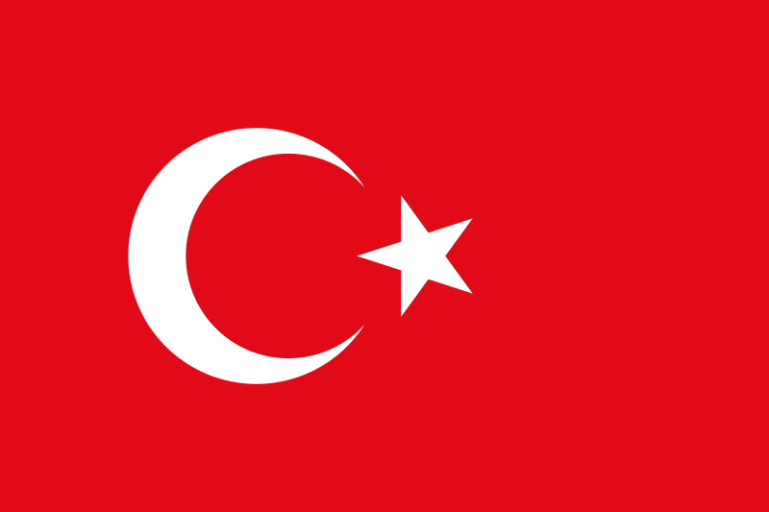

Country: Turkey

Committee: Food and Agriculture Organization (FAO)

Topic: Combating Food Insecurity and the Risk of Famine

Turkey known officially as the Republic of Turkey, is a Eurasian country located in Western Asia (mostly in the Anatolian peninsula) and in East Thrace in Southeastern Europe. The surface area of Turkey is 814.578 square kilometers. The European and the Asian continents are separated by the Sea of Marmara, Bosphorus and the Dardanelles. Turkey is surrounded by sea on three sides, with the seashore length of Turkey amounting to 8333 kms. It is possible to enjoy the four seasons at a time.

It was developed with the aim of institutionalizing the third personal space capacity. This financing will provide technical assistance for farmers' payment, prepare training programs for public institutions, develop a monitoring and analytical system on national and international agricultural opportunities and market opportunities for more effective decision-making, and finally, provide technical assistance to analyze and support the policies of the support. Since rural women and men may face different barriers to accessing solution development opportunities and rural transition resources, gender-sensitive treatment is needed in training programs for both institutions and farmers. Gender differences in education, training and skills, gender discrimination, limited mobility and gender stereotypes directly limit women's transition rates. By providing quality gender-sensitive information, activities and jobs to women, it will contribute to gender equality in rural areas. FAO was seeing gender differences while continuing its activities on this brightness.

In this context, FAO is committed to developing institutional and technical capacity in different areas related to sustainable forest and natural resources management and food security, providing both direct support to farmers and growth and extension services in the field of agriculture, agriculture and novelization, women and protection by strengthening local and national governments. It engages with relevant processes, including non-state actors, as appropriate to improve empowerment.

Cooperation within this brightness area also provides freedom to improve public performance for the effective formation of migration. In addition, the result of the collaboration will be to ensure increased cooperation and coordination between state administrations, NGOs and the private sector, including the integration of a gender-sensitive democratic social policy into existing social protection policies, e-agriculture strategy components and expanded consultancy and publishing services we offer.