Committe: DISEC(Disarmament and International Security Committee)

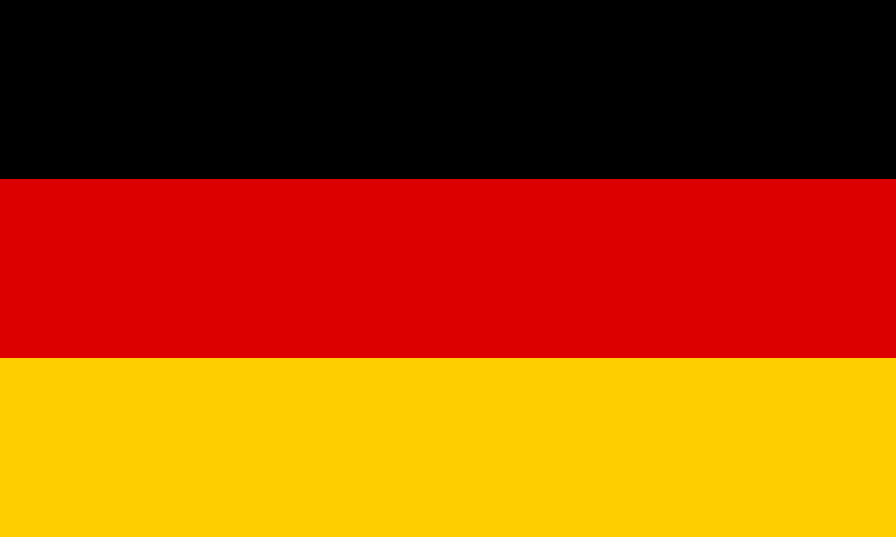

Country: Germany

Agenda Item: Proliferation of Nuclear Weapons in Russo- Ukranian War

Germany, as part of the European region with a population of about 83 million, diversified economy based on automotive industry, engineering and technology is going to perform as Disarmament and International Security Committee (DISEC) concerning the fact that the WMD proliferation in the RUW is very critical.

As part of the nation which is striving for peace, stability, and collaboration amongst countries, Germany upholds the view that the nuclear weapon proliferation should be completely stopped due to the fact, especially in conflict zones, they are the most hazardous. As immediate actions is the role of diplomatic actions in affording effective measures the prevention of escalation of conflicts-nuclear crises stand important.

When we consider the background of the Russo-Ukrainian war which is characterized by the historical hostilities and geopolitical intricacies of the present time, it becomes clear that Germany notices the crucial contributions of Russia and Ukraine and traceable consequences the conflict can have in the long-term perspective.

Germany favors the framework of rapport, weapons control and also regional cooperation for a comprehensive approach to the issue of the proliferation nuclear arsenals. Compliance with international treaties like NPT (Non-Proliferation of Nuclear Weapons) Treaty is a prime method to deprive tyrants from their purchase and construction of nuclear weapons.

Apart from that, Germany calls upon the UN Secretary General and the international partners, who to take more action and initiate diplomatic efforts leading to reduction of tensions in the conflict between Russia and Ukraine as well as generally promoting the peace process through dialogue and negotiation. Measures for confidence building and inclusive transparency serves as powerful tools that can minimize the probability of misjudging or miscalculating the situation.

Lastly, Germany pushes for each member state to regard diplomacy, dialogue, and cooperation as key principles while defeating proliferation of nuclear weapons linked with the current military confrontation in Ukraine, abiding by the international agreements earliest on peace and security. What should be actually mentioned is that every paragraph deals with the subject, which is confirmed by the use of relevant and dependable of souces, so the discourse is accurate and reliable.