Committee: DISEC (Disermament & International Security)

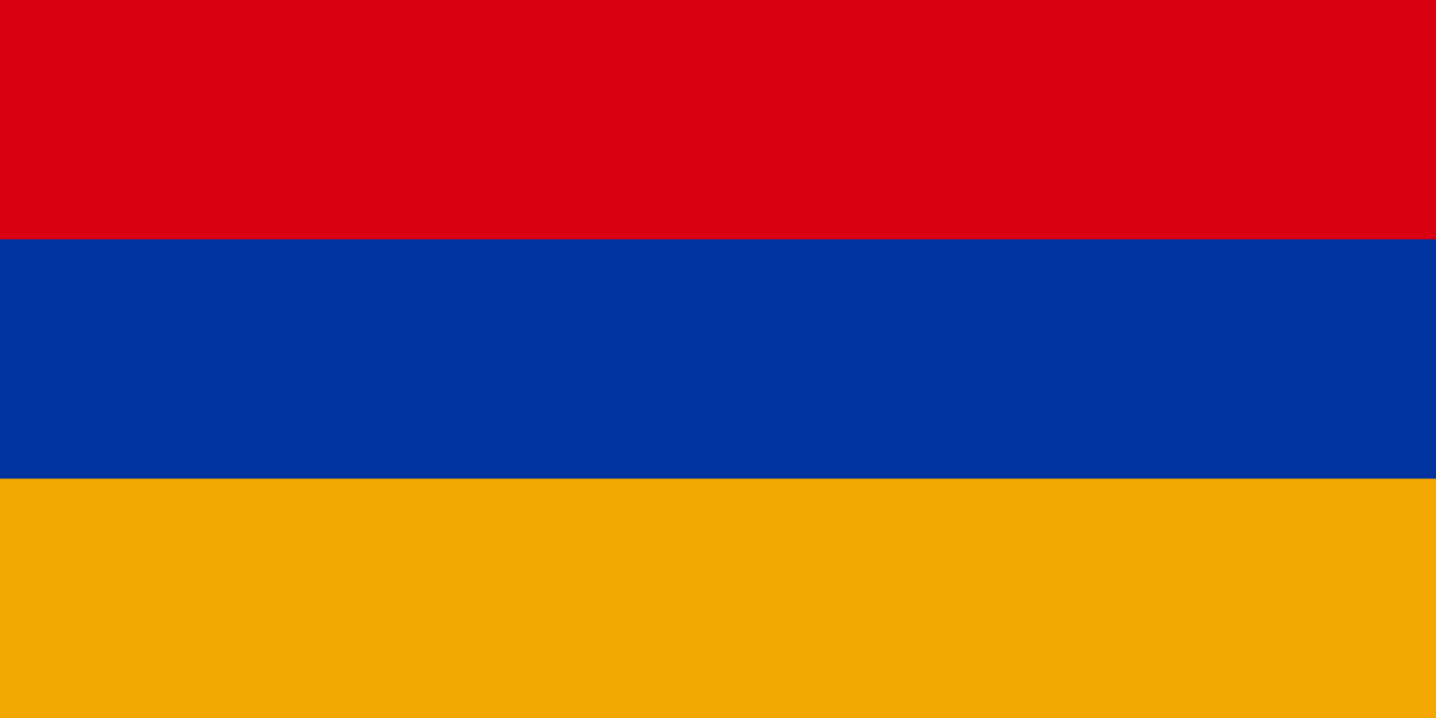

Country: Armenia

Agenda Item: Proliferation of Nuclear Weapons in Russo-Ukranian War

Armenia is a country located in the South Caucasus region of Eurasia. It has no coast to the sea. Armenia’s economy is largely based on industry and mining. The population of Armenia is two million eight hundred thousand. The capital of Armenia is Yerevan. %25 of the country’s land is used in agricultural activities. Armenia is famous for its wine and brandy. The flag consists of three colors; red, yellow, dark blue.

Nuclear armament has increased significantly in recent times. With the development of technology , it began to play an important role in wars. Especially in the recent Russia-Ukraine war. In this war, the nuclear powers avaliable made the war even bigger and the war became more dangerous. The escalation of war also harms civillians. The loss of life is increasing and causing great damage to the country.

We think that the proliferation of nuclear weapons is very dangerous for the world. If it continues to increase like this, it may cause great harm to society, so we want it to be prevented. We are in favor of solving war problems and ensuring peace.