Country:Italy

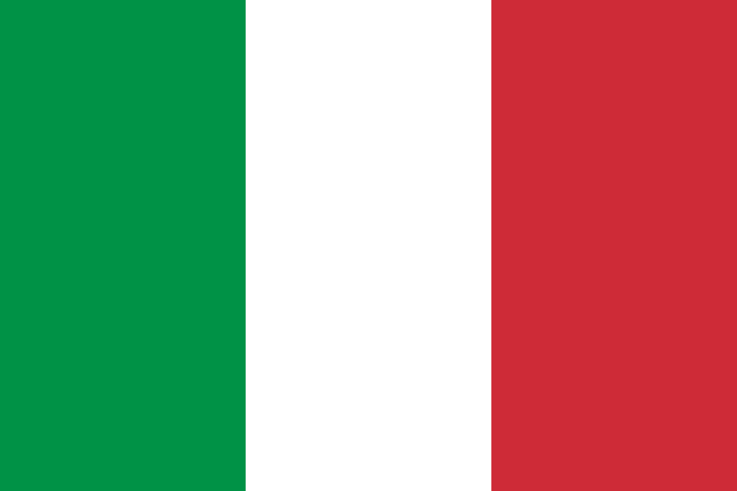

Committe:UnWomen

Agenda Item:Medical negligence of women

Italy is a country in Southern Europe, with most of it located on the Italian Peninsula. It is a country with a surface area of ​​301,340 square kilometers. With a population of approximately 60 million, Italy is the third most populous country in the European Union. Its capital and largest city, Rome, has been the center of the Catholic Church since ancient times. The main international organizations of which Italy is a member are: European Union (EU), World Trade Organization (WTO), United Nations (UN), Council of Europe, North Atlantic Treaty Organization (NATO).

First, available litigation documents were searched on “China Judgment Online” using keywords including medical errors. Second, we compiled a database with 5,072 disputes. After using systematic random sampling to retain half of the data, we removed 549 unrelated cases. Then, we hired two frontline physicians to review the documents and independently judge the medical errors and specialties involved. A third physician further considered the divergent results. Finally, we compared the medical compensation between older and younger groups and medical errors and specialties among older patients.

Older patients experienced different medical errors in divergent specialties.

Research was conducted into the most frequent causes of “malasanità” (medical malpractice) and/or “malpractice” in Italy, seeking to understand the reasons for this complex phenomenon and to provide a response to the many open questions affecting the Italian health service. Our research is based on the consultation of specialised journals and scientific periodicals, institutional, medical and scientific websites, websites of patients and citizens associations and documents published by Italian Medical Associations and insurance companies. The aim of this research is to quantify the problem and propose a series of evaluations and recommendations designed to promote the improvement of health care in Italy.

Women in Italy access medical services through the country’s public healthcare system, managed by the Ministry of Health (Ministero della Salute). Care is available to all Italian citizens and legal residents as long as they have an SSN health card (tessera sanitaria).