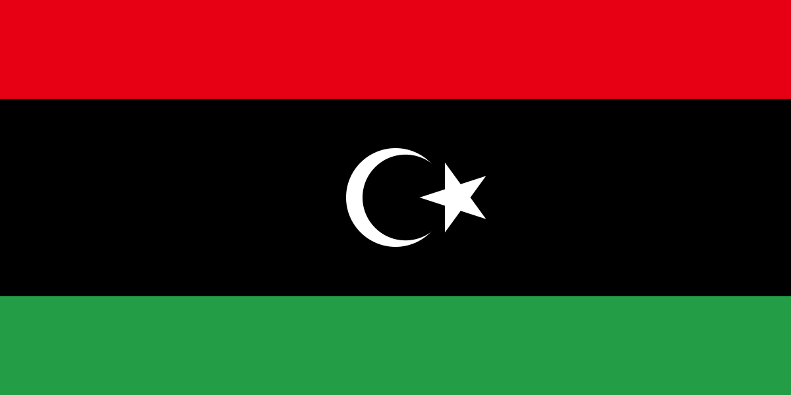

Committee: United Nations Office On Drugs And Crime (UNODC)

Topic: Combating human trafficking for organ removal

Country: Libya

Delegate: Alya Ece Bayram

Our committee, UNODC utilizes a trio of vital competencies in its operations; studies, steerage, and support for governments. The UNODC's primary focus is to provide a coordinated and comprehensive response to the interconnected challenges arising from illegal drugs and criminal sports. Its objectives extend beyond simply addressing immediate issues, to sell global safety, social justice, and long-term improvement.

Human trafficking in its basics is the recruitment, transportation, transfer, harboring, or receipt of people through force, fraud, or deception, to exploit them for profit. It constitutes a crime against humanity. As reported over the past five years, human traffickers exploit domestic and foreign victims in Libya. Instability, conflict, and lack of government oversight and capacity in Libya continued to allow for human trafficking crimes to persist and be highly profitable for traffickers. Trafficking victims – both adults and children – are highly vulnerable to extreme violence and human rights abuses in Libya by governmental and non-state armed groups, including physical, sexual, and verbal assault; abduction for ransom; extortion; arbitrary killings; inhumane detention; and child soldiering.Migrants in Libya are extremely vulnerable to sex and labor trafficking, including those seeking employment in Libya or transiting Libya en route to Europe. An international organization reported indicators of exploitation and abuse amounting to trafficking are experienced by 76 percent of men, 67 percent of women, and 77 percent of children and youth transiting Libya.

At this conference, we hope to further informed dialogue and explore potential avenues to not only help our country but also reach out to all of those who are in need. We truly wish that this quandary ends in a peaceful manner.

Sources Used:

<https://www.state.gov/reports/2023-trafficking-in-persons-report/libya/>

<https://carnegieendowment.org/sada/90361>