**Country: Germany**

**Agenda Item: Preserving Freedom of Press**

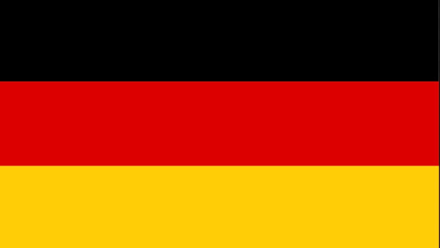**Committee: SOCHUM**

Germany has attended to UN in 1973 for protecting human rights, to protect people, to be an unity with other countries. Also Germany is a part of NATO. The aim of NATO is to ensure the freedom and security of their members political and military means. NATO supports democratic values and provides their members with defense and security-related consultation and cooperation to solve problems, build trust and prevent conflicts in the long term. That is why Germany has attended to NATO.

Germany is located on the European continent. Germany’s capital is Berlin. The economy is strong. The heart of the car industry beats in Germany. Germany takes strong steps to make their citizens lifestyles better. Also Germany is a part of EU (European Union).

Media is 4th power in Germany. The media serves as a kind of bridge between citizens and politics. A free and independent media has a central and unique role in democracies. Both the press, radio and television organizations contribute to the process of citizens forming their own opinions by informing them independently of state institutions and parties. This role of the media in Germany is guaranteed by the German constitution. So Germany has laws to protect that right. Germany cares about that important topic.

But sometimes things don't go on the right way. Germany has to behave more serious about peoples rights. Must not protect the government for wrong things.

Germany has done lots of things for media and citizens . Regional radio and television broadcasting, which is the nine state radio and television organizations of the federal states, is subject to public law. TV organizations can broadcast advertisements for 20 minutes a day.

To protect government and citizens they have laws.

Source: deutschland.de and wikipedia

**hdhsmsjjssj**