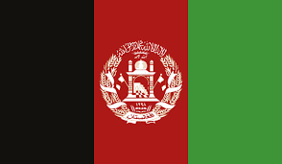

Country Afghanistan:

Committee: UN Women

Topic: Women’s medical negligence

We as the delegation of Afghanistan believe women and young girls have as much right to access medical care as any other gender does. Afghanistan is in the need of more doctors and healthcare providers, specifically women doctors. The reproductive and maternal care is poor and lacks quality in Afghanistan. Due to the Taliban Regime in our country we are unable to support our women and children the necessary medical care they need and are not in the position to support medical education for our women.

During the past 20 years,social and political rebellions have disrupted the way of life in Afghanistan. The Taliban Regime is very religious where they are using Islamic Law. Because of this they are using religion to do whatever they want and hide behind the Islamic Law. In Afghanistan many women are facing discrimination in the health sector. Most Afghan women can’t get the care they need and the quality of the care is often poor. Many women are not in the economic position to afford costly medicines they need or even a ride to the hospital which is usually further from their neighborhood.

All humans are bound to medical care throughout their lives which is why we as Afghanistan want to work on promoting better education and support for our women where more women will be able to study medicine and become healthcare providers, providing gender equal edical care for both women and children, enforce laws with the help of the UN that will help protect women’s and children’s rights to legal and lawful medical care that they deserve and many more solutions that will put an end to this discrimination that goes against human rights.

We as Afghanistan are open to cooperate to solve this problem and provide better medical care for all women.