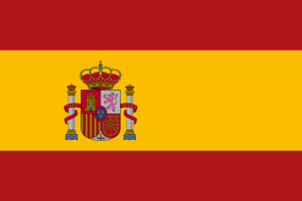

Country: Spain

Committee: SOCHUM

Topic: Preserving Freedom of the Press

Spain is a country in the Southwestern Europe. Due to where the country is located, it has the Mediterranean Sea in the south and the Atlantic Ocean in the north. Spain is neighbor to France and Portugal. Also spain is the biggest country in Europe after France. The country has been a member in Eurpion union since 01/01/1986 and its a member in NATO since 05/30/1982 too.

We can’t underestimate the press's importance for a country. Democracy’s backbone is an independent, free and responsible Media. Thats why Spain has been a defender of press freedom throughout its history. . İn section 20 of its constitution (which was written in 1978), the freedom of press in Spain is quaranteened.

Spain ensures that their people can access information amd express their ideas without fear for their safety and more. That is why Spain supports the press by, guaranteeing press protections. As addition, in order to promote press media around the world, Spain collabrates with international media organizations.

To preserve freedom of press, Spain proposes to support the press financially and legislatively so that we can ensure that journalists are able to do their jobs safely and without the fear of reprisal. combat misinformation and disinformation besides promoting international cooperation. For this aim we can partner with other countries and international organizations. Spain recognizes the important opportunity to preserve the freedom through international efforts, and it believes that increased efforts will further prevent losing the freedom of personal thoughts and beliefs from getting spread from worldwide.

Resources:

<https://blogs.fcdo.gov.uk/petermillett/2012/02/13/the-responsibility-of-the-press/#:~:text=The%20backbone%20of%20any%20democracy,inform%2C%20criticise%20and%20stimulate%20debate>

<https://en.wikipedia.org/wiki/Freedom_of_the_press_in_Spain#:~:text=The%20freedom%20of%20the%20press,dictatorship%20of%20General%20Francisco%20Franco>

<https://ipi.media/strengthening-press-freedom-at-home-and-abroad-10-recommendations-for-the-worlds-democracies/>

<https://www.nmun.org/assets/documents/nmun-pp-guide.pdf>

<https://p.calameoassets.com/201123180447-80c4e689ad16cf2b87163b604a3bb02b/p1.jpg>