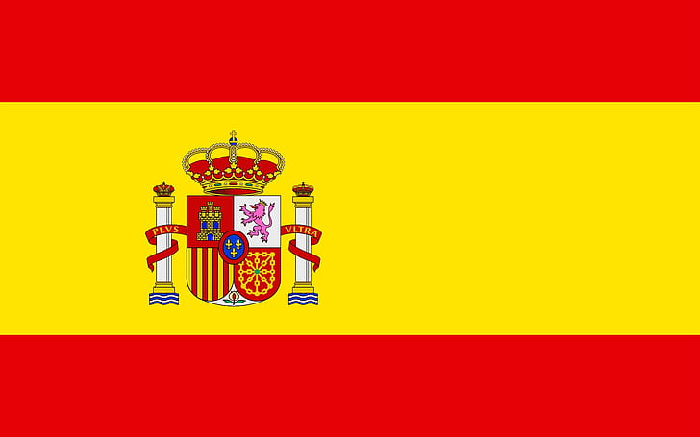**Committee:** DISEC (Disarmament & International Security Committee)

**State:** The Kingdom of Spain

**Topic:** The Regulation of Chemical Weapon Possession and Usage

Spain has a long-standing history of advocating disarmament and non-proliferation efforts and it is a contributor of the Chemical Weapons Convention (CWC) since 1997. Spain has actively contributed and still contributes to the elimination of chemical weapons stockpiles and the promotes uses of chemistry for international peace. Despite endorsement of nuclear weapons for regional security, Spain has participated in several international agreements and meetings that prioritize elimination of chemical weapons such as poisonous agents. Spain’s commitment to disarmament is underscored by its adherence to various international agreements and initiatives aimed at eliminating the spread of such weapons.

**Current Challenges:** Clashing with the public opinions, which polled to be above 80% against, Spain has not endorsed TPNW and nuclear disarmament. Being a part of the North Atlantic Treaty Organization, Spain prioritizes collective defense.

**Policy Recommendations:** Spain is aware of the dangers arising from usage and possession of chemical weapons and looks forward to their elimination. However, Spain believes that this elimination shall be mutual and it advocates a gradual approach that considers international and collective defense as well as existing alliances.

**Strengthening Compliance Mechanisms:** Spain proposes monitoring and verification measures to ensure full compliance with the Chemical Weapons Convention and any other conventions regarding chemical weapons. Spain looks positive to strengthening the role of the Organisation for the Prohibition of Chemical Weapons (OPCW) in order to expand influence over investigation of usage/possession of such weapons and enforcing adherence to the Convention.

**Enhanced International Cooperation**: Spain approves fostering greater collaboration among other states, international organizations, and civil society to share information, intelligence, and practices in countering chemical weapons proliferation. Promotion of capacity-building initiatives to assist states in enhancing their capabilities to prevent, detect, and respond to chemical attacks is one of the goals of Spain.

**Addressing Emerging Threats:** Spain strongly supports developing comprehensive strategies to address emerging threats posed by non-state actors and terrorist groups. Enhance border security measures and promote information-sharing mechanisms to prevent the illicit trafficking of chemical precursors and technologies. Spain strongly believes that cooperation between states is extremely crucial to eliminate risks of chemical weapons to the wrong hands.

**Promoting Accountability and Justice:** Holding perpetrators of chemical attacks accountable for their actions through national and international judicial mechanisms and bringing them to international justice is essential. Spain is ready to support efforts to strengthen the legal framework for prosecuting individuals responsible for the production, trafficking, or use of chemical weapons, in accordance with international law.

**Preventive Diplomacy and Conflict Resolution:** Spain is against conflict between states and believes that diplomacy shall be the top priority for elimination of conflicts. It looks forward to diplomatic missions between states in order to prevent future conflicts.

**Points to be Addressed**

**How should member states further expand the existing conventions created to inhibit the possession and usage of chemical weapons?**

Spain considers exploration of avenues between major states to strengthen the implementation and enforcement of existing conventions, such as the Chemical Weapons Convention (CWC). This could include enhancing verification measures, broadening the scope of prohibited activities, and establishing mechanisms for addressing emerging threats, such as non-state actor involvement in chemical weapons proliferation. Additionally, promoting universal adherence to the CWC and encouraging non-signatory states to join the convention can bolster its effectiveness in preventing the possession and usage of chemical weapons.

**How should the members of the committee control the acquisition of chemicals used in the production of chemical weapons?**

Member states should enhance regulatory frameworks and export controls to prevent the diversion of chemicals used in the production of chemical weapons. Strengthening international cooperation and information-sharing mechanisms can facilitate the detection and interdiction of illicit chemical shipments. Additionally, promoting responsible chemical management practices and providing assistance to states in enhancing their chemical security infrastructure can mitigate the risk of chemical weapons proliferation.

**How should the committee react to the stockpiling of chemical agents and weapons? If it is monitored, should it be safe?**

The committee should prioritize the safe and secure destruction of chemical weapons stockpiles in accordance with the provisions of the Chemical Weapons Convention. Member states should support efforts to monitor and verify the destruction process to ensure compliance with international obligations and prevent the diversion of chemical agents for illicit purposes. Additionally, providing technical and financial assistance to states in need can facilitate the safe disposal of chemical weapons and minimize environmental risks.

**What can be done to make the Chemical Weapons Convention (CWC) a universal convention?**

Member states should engage in diplomatic outreach and advocacy efforts to encourage non-signatory states to join the Chemical Weapons Convention (CWC). This could involve highlighting the benefits of accession, such as enhanced security and international cooperation, and addressing concerns or reservations that may prevent states from joining the convention. Additionally, offering technical assistance and support to states in meeting the requirements for accession can facilitate the expansion of the convention's membership and strengthen its effectiveness in preventing chemical weapons proliferation.

In conclusion, by addressing these key considerations, member states can effectively regulate chemical weapon possession and usage, enhance global security, and uphold the principles of disarmament and non-proliferation.

**Conclusion:** The Kingdom of Spain reaffirms its commitment to upholding the norms and principles of the Chemical Weapons Convention and advancing the global disarmament and non-proliferation agenda. By working together with the international community, Spain believes states can effectively regulate chemical weapon possession and usage, promote peace and security, and build a safer world for future generations.

Bengü Biçer

Delegate of Spain

Disarmament and International Security Committee (DISEC)

**References**

* <https://www.opcw.org/media-centre/news/2018/10/spains-minister-foreign-affairs-visits-opcw>
* <https://www.opcw.org/media-centre/news/2022/11/spain-contributes-eu200000-opcw-assistance-and-protection-activities>
* <https://emad.defensa.gob.es/en/prensa/noticias/2021/12/Listado/211221-uve-inspecciones-opaq.html>
* <https://www.opcw.org/media-centre/news/2020/09/opcw-director-general-visits-spain>