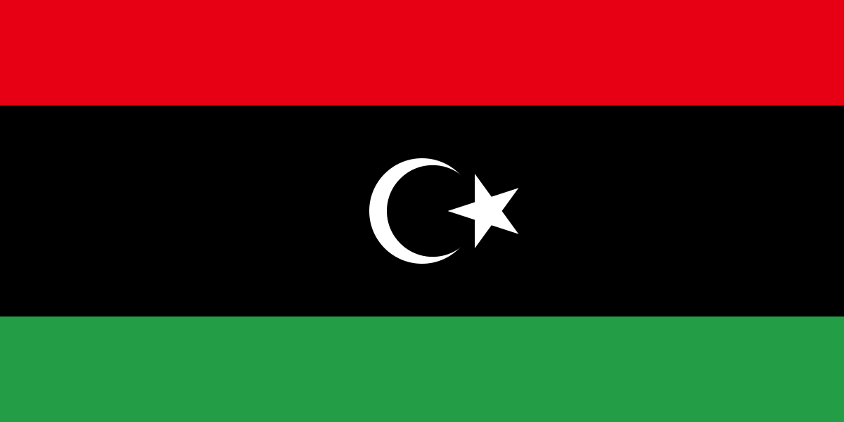

**Country:** Libya

**Committee:** General Assembly 1: The Disarmament and International Security Committee

**Agenda Item:** The Regulation of Chemical Weapon Possession and Usage

The Republic of Libya, like other nations, is likely to emphasize the importance of international cooperation and adherence to treaties and conventions aimed at prohibiting the development, production, and use of chemical weapons. The country may advocate for robust verification mechanisms, inspections, and strict adherence to international norms to prevent the proliferation of such weapons. Libya has been a party to the Chemical Weapons Convention (CWC) since its accession in 2004. Consequently, it would be expected to align with the principles outlined in the convention, which emphasizes the complete elimination of chemical weapons stockpiles and the prevention of their re-emergence.

During World War II, Libya was of strategic importance and saw significant military engagements between the Allied and Axis powers. Italy, under Benito Mussolini, had established control over Libya before the war, and the region became a battleground between Axis forces (primarily Italy and later Germany) and the Allied forces (primarily the British Commonwealth).As for the use of chemical weapons during World War II, it's crucial to note that the widespread use of chemical weapons seen in World War I was largely avoided in the Second World War. There were, however, instances of limited chemical weapons use by both Axis and Allied forces.Regarding Libya specifically, it was a theater of conflict where conventional warfare and strategic considerations took precedence over the use of chemical weapons. Libya did not play a central role in the use or regulation of chemical weapons during World War II. After the war, Libya gained independence in 1951, and its modern history and international interactions developed from that point onward. The regulation of chemical weapons globally, as discussed in forums like the United Nations and through international treaties, has evolved over the years, with Libya participating in these discussions as a sovereign nation.

Enhance verification and transparency in international agreements, especially the Chemical Weapons Convention (CWC). Encourage all nations to join the CWC for a more comprehensive global framework. Support nations, especially those with limited resources, in developing technical capabilities for detecting and disposing of chemical weapons. Foster collaboration among nations in specific regions to address challenges related to chemical weapons.Establish a fund for international humanitarian aid to support victims of chemical weapons attacks.Develop international standards to safeguard critical infrastructure against cyber threats related to chemical weapons.Promote collaborative research to advance technologies for the detection and identification of chemical weapons.These proposals reflect Libya's commitment to global security and stability through collective action.