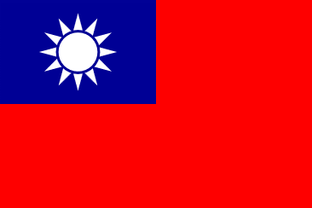 **Committee**: GA 3: Social, Humanitarian, Cultural Committee (SOCHUM)

**Country:** Taiwan

**Agenda item:** Search for solutions to human rights violations resulting from ethnic differences.

The capital of Taiwan is Taipei. It is an East Asian island country located on Taiwan Island and Penghu, Kinmen, Matsu and some other islets. Its surface area is 36,197 square kilometers. Today, the Republic of China is recognized by only 23 countries; However, many countries have unofficial economic and cultural relations. Nowadays, the term China is generally used to refer to the People's Republic of China, while the Republic of China is called Taiwan.

Taiwan's economy is a highly developed market economy. Its currency is the New Taiwan Dollar. It is the 8th largest economy in Asia and the 18th largest economy in the world according to purchasing power parity, which allows Taiwan to be included in the group of developed economies by the International Monetary Fund. It is measured by the World Bank in the high-income economies group. Taiwan is the most technologically advanced computer microchip manufacturer in the world.

The two conventions signed by the Republic of China in 1967, together with the Universal Declaration of Human Rights, constitute the International Human Rights Law, which explains the basic and most important standards and legal obligations in the protection of human rights all over the world. Their implementation is valid for each individual.Republic of China; By undertaking the International Review, it demonstrates its commitment to the implementation of the two conventions, as well as its proactive involvement in international human rights relations. Headings under the review; the right to work, title justice, the rights and interests of indigenous people, the right to a decent standard of living, fair trial and freedom of speech.

Thank you

Resources:

<https://www.roc-taiwan.org/tr_tr/post/679.html>

<https://tr.wikipedia.org/wiki/Tayvan>