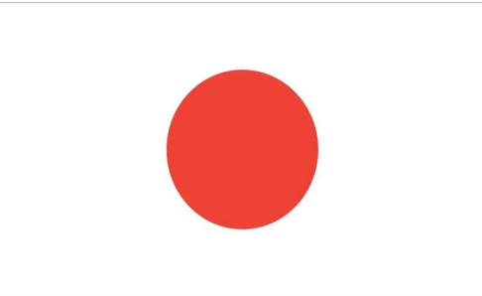Position Paper. Japan FAO2

Japan is a country located in east asia. The capital of Japan is Tokyo. The population of the country is 125,1 million. Japan consits of 97,8% Japanese ,0,6% Chinese, 0,4% Korean and 1,2% other races. It is among the founding members of the Asia Europe meeting and the International Maritime Organization. Japan is a country that attaches importance to food safety and raises awareness of it’s people on this issiu. Without food safety, food-based diseases will cause the emergence of many new diseases in the world. That’s why millions of people may die from diseases just like Covid-19. It has been announced that 80% of the recent increase in food insecurity is due to human carelessness , and 20% is caused by people knowingly. Food insecurity is more common in countries that are at war or have experinced a major disaster. While food insecurity continues, choronic maltreatment of patients is not reflected in their posts.

Japan has touched on this issiue a lot in the past. For example the president of Japan toured schools with the head of education and training in Japan and taught children about this subject. Japan recently signed an agreement with Asian and some European countries on food insecrity.

In our opnion, the solution to this problem is to help countries end hunger with a portion of the taxes collected at the end of each year. Because hunger can be solved with the help of money. As the United nations, stores should be opened in every city of every country.