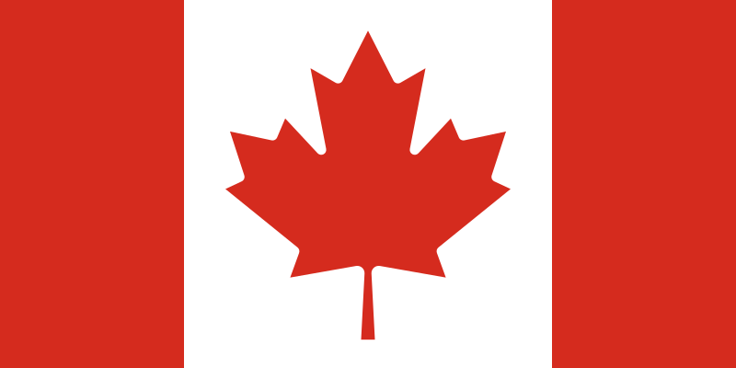Committe: Specpol (Special Political and Decolonization Committe)

Country: Canada

Agenda Item: Effects to Foreing Companies on the Economies and Politics of Central American Nation

Canada is a country in North America. Consists of ten states and three territories. It is the second largest country in the world after Russia in terms of surface area. Ottawa is the capital city of Canada and the three largest cities are Toronto, Montreal and Vancouver.

The economy and politics of Central America are significantly influenced by the activities of foreign companies. Canada has many companies according to their sectors. Pancanadian Petroleum Limited is one of the companies that contribute to America’s economy and politics. The pan-Canadian oil company's exploration, development, production and sales activities include crude oil, natural gas and natural gas liquids. Its operations are mainly concentrated in western Canada. Thanks to this company, Canadian exports to the USA reached 72 million Canadian dollars, and exports of oil and natural gas to the USA increased by 24 million barrels.

Thank you

References:

[Canada - Wikipedia](https://en.wikipedia.org/wiki/Canada)

[Kanadalı enerji şirketleri - Sayfa [1] - Dünya ansiklopedik bilgi (swewe.net)](https://tr.swewe.net/word_show.htm/?332902_1&Kanadal%C4%B1_enerji_%C5%9Firketleri)