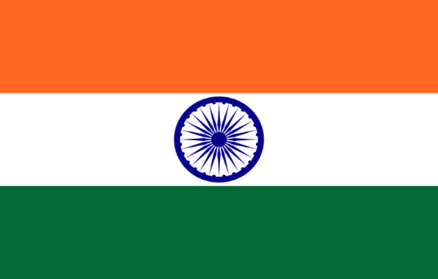Committee: United Nations Environmental Problems(UNEP)  
Country: Bharat  
Agenda item1: Assessing the Current State of the Climate Crisis,  
Agenda Item 2:Environmental Problems Regarding Cities  
School: Ankara Education Institutions Doktorlar College  
Delegate: Melis Talu

Bharat, is a country located in South Asia and is known for being the first populated country as well as having the seventh largest land area in the world. Bharat has coast sites to Indian Ocean, the Arabian Sea, the Bay of Bengal. Furthermore, it shares land borders with Pakistan to the west; Nepal, Bhutan and China to the north; and Myanmar and Bangladesh to the east. Bharat's economy is the seventh best in the world in nominal terms and the third best in terms of purchasing power parity. The country's economy has been growing at an average rate of 7% for 20 years and is classified as a newly industrialized country.

The climate crisis continues to be one of the biggest problems of our world. Its effects are long-lasting and permanent. A lot of work is being done on the climate crisis in the world. For example, the Paris Agreement. The Paris Agreement is a legally binding international treaty on climate change. It was adopted by 196 Parties at the UN Climate Change Conference (COP21) in Paris, France, on 12 December 2015. It entered into force on 4 November 2016. Bharat has also become a party to this agreement. To add; Bharat is in danger because of rising sea levels due to the climate crisis. In fact, it is the 5th most dangerous country in the World.

Environmental problems are disruptions in the functioning of ecosystems. Pollution comes first among the top 20 environmental problems. This pollution can consist of many things such as air pollution, water pollution and soil pollution. Moreover, these problems can be caused by humans or natural. So how do these environmental problems affect cities? In order to help its citizens, the Bharat government temporarily closed schools and 5 factories in New Delhi, which was fighting against air pollution. Even though Bharat has difficulties in this regard, the government continues to do its best.

Bharat, where Per capita emissions remain much lower than developed countries, has made rapid progress in the field of renewable energy, and aims to reach net zero in 2070. In addition, Bharat called for help for countries that do not have enough economic power to combat the climate crisis and stated that countries with good economies should provide financial support to poor countries in this regard. In addition, Bharat thinks that reducing, recycling and reusing will help reducing environmental problems.

Bibliography

<https://www.conserve-energy-future.com/15-current-environmental-problems.php>  
  
<https://en.wikipedia.org/wiki/Environmental_issues>  
  
<https://en.wikipedia.org/wiki/India>  
  
<https://unfccc.int/process-and-meetings/the-paris-agreement?gad_source=1&gclid=CjwKCAiA3JCvBhA8EiwA4kujZnXy_59_AVHEJEIUAVuGNj5764LLRg_IQ8mIJvXQmLnz_gUdRTbLLxoC8LkQAvD_BwE>  
  
<https://en.wikipedia.org/wiki/Economy_of_India>