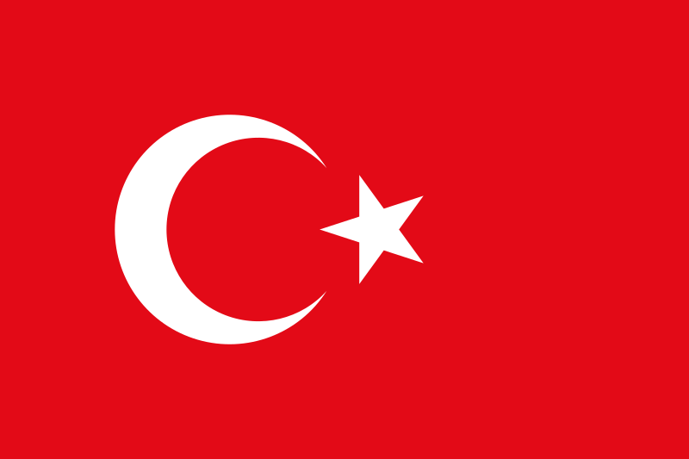Committee: Disarmament and International Security

Country: The Republic of Türkiye

Agenda Item: The Regulation of Chemical Weapon

Possession and Usage

School: Ankara Education Instituitions Doktorlar College

Delegate: Defne Şener

Türkiye, officially The Republic of Türkiye is a state located in Eurasia. Türkiye has cost sides to the Aegean Sea, Black Sea, Mediteranean Sea and Marmara Sea. It is the 37th largest country in the world. Türkiye’s economy is the 17th best economy globally. Türkiye is a founding member of G20 and OECD. There are 81 cities and 85 million population inside. Majorly Turks. After Turks, Kurds and Arabs have the majority. Türkiye is a democratic republic. The official language is Turkish. Türkiye borders Syria, Iran, Iraq, Azerbaijan, Georgia, Bulgaria and Greece. Ankara is the capital of Türkiye and after Istanbul, Ankara is the most populated city of Türkiye.

The Law No. 5564, concerning the prohibition of chemical weapons development, production, stockpiling, and use, was ratified by the General Assembly of the Grand National Assembly of Türkiye on December 14, 2006, and came into sequel on December 21, 2006, in accordance with Article VII of the Convention on the Prevention of Chemical Weapons (CWC). Beside this Türkiye has membership in the Nuclear Non-Proliferation Treaty (NPT)in 2000 , Australian Group, which is a group was inaugurated in 1985 to rulet he export dual-use materials and Technologies to intercept the spreading of chemical and biological weapons.

Türkiye has been engaged in prolonged struggle against terrorism for several decades. Considerable problems cause of terrorism involves chemical weaponry and agents rustling, cheifly in internal turmoils in states, which is inadmissible for the Republic of Türkiye. Chemical weapons should never possessed by terrorist. Due to that chemical weapons and substances, which are currently prohibited in accordance with international treaties should never be stockpiled in the bases of states.

To conclude Türkiye is in a search for ‘How to prevent chemical weapons against terroist’s jurisdiction?’ and ‘How it is possible to put an end to great threats, since chemical weaponry, as a comittee?’. Despite our irresistible efforts to find sustainable solutions upon these enigmas a cooperation is essential with all member states in this conference.

BIBLIOGRAPHY:

[https://tr.wikipedia.org/wiki/T%C3%BCrkiye_ekonomisi - :~:text=T%C3%BCrkiye%2C%20OECD%20ve%20G20'nin,ise%20en%20b%C3%BCy%C3%BCk%207.%20ekonomisidir.](https://tr.wikipedia.org/wiki/T%C3%BCrkiye_ekonomisi#:~:text=T%C3%BCrkiye%2C%20OECD%20ve%20G20'nin,ise%20en%20b%C3%BCy%C3%BCk%207.%20ekonomisidir.)

[https://tr.wikipedia.org/wiki/G20 - :~:text=Daha%20%C3%A7ok%20%C4%B0ngilizce%20Group%20of,k%C4%B1saltmas%C4%B1%20olan%20G20%20ad%C4%B1yla%20bilinir.](https://tr.wikipedia.org/wiki/G20#:~:text=Daha%20%C3%A7ok%20%C4%B0ngilizce%20Group%20of,k%C4%B1saltmas%C4%B1%20olan%20G20%20ad%C4%B1yla%20bilinir.)

[https://www.mfa.gov.tr/silahlarin-kontrolu-ve-silahsizlanma.tr.mfa - :~:text=T%C3%BCrkiye%2C%20NTG'ye%202000%20y%C4%B1l%C4%B1nda,ye%202000%20y%C4%B1l%C4%B1nda%20%C3%BCye%20olmu%C5%9Ftur.](https://www.mfa.gov.tr/silahlarin-kontrolu-ve-silahsizlanma.tr.mfa#:~:text=T%C3%BCrkiye%2C%20NTG'ye%202000%20y%C4%B1l%C4%B1nda,ye%202000%20y%C4%B1l%C4%B1nda%20%C3%BCye%20olmu%C5%9Ftur.)