**Country: Pakistan**

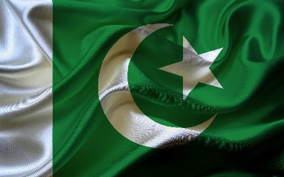

**Committee: The United Nations Disarmament and International Security Committee (DISEC)**

**Topic: Advancing Global Efforts for Nuclear Non-Proliferation and Disarmament**

Pakistan is a country between the Himalayas and the Arabian Gulf. The land has a total area of 796,100 km² and a total coastline of 1,046 km. This land area is approximately 114% of the area of Texas. Pakistan is thus one of the largest countries in Asia and the 35th biggest in the world. Most of the population resides within rural regions. Pakistan officially joined the United Nations on 30 September 1947 just over a month after it came into existence. Today, it is a charter member and participates in all of the UN's specialized agencies and organizations.

Pakistan is in support of strengthening the Nuclear Non-Proliferation Treaty.This treaty is the bedrock of the global non-proliferation regime. Pakistan believes that all states need to adhere to the NPT and fulfill their obligations under the treaty. Pakistan supports the promotion of dialogue and confidence building and negotiating a Fissile Material Cut-off Treaty. This would ban the production of fissile material for nuclear weapons, which is an important step towards disarmament. We should work together to prevent further nuclear proliferation, accelerate disarmament negotiations and create a world free of nuclear weapons.

Pakistan believes that nuclear non-proliferation and disarmament are critical for the survival of humanity and global peace. We call on all nations to join us in pursuing a world without nuclear weapons. Pakistan stands prepared to play a very constructive role in advancing these efforts and calls on all States to work together for a world free of nuclear weapons.

**References:**

* United Nations Treaty on the Non-Proliferation of Nuclear Weapons (NPT)
* United Nations General Assembly Resolution on the Comprehensive Nuclear-Test-Ban Treaty (CTBT)
* United Nations General Assembly Resolution on the Fissile Material Cut-off Treaty (FMCT)
* Statement by the Prime Minister of Pakistan on Nuclear Disarmament and Non-Proliferation