**Country: South Africa**

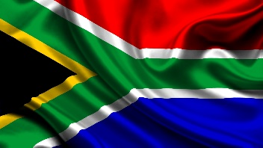

**Committee: The United Nations Disarmament and International Security Committee (DISEC)**

**Topic: Advancing Global Efforts for Nuclear Non-Proliferation and Disarmament**

South Africa, officially the Republic of South Africa is the southernmost country in Africa. It has an area of 1,219,090 square km. Its capital is Pretoria and its largest city is Johannesburg. Zulu, Xhosa, Afrikaans, English, Tsonga, Swazi, and Venda are some of its official languages. South Africa was one of the 51 founding members of the United Nations in 1945. Since its establishment in 1945.  
Nuclear Non-Proliferation and Disarmament have long been priorities for the Republic of South Africa. As a country that voluntarily ended its nuclear program in the early 1990s, it recognizes the serious dangers created by the spread of nuclear weapons and the importance of disarmament in ensuring global peace and security. All nations must meet their obligations under the NPT and work together toward the common goal of a world free of nuclear weapons, South Africa urges countries to fulfill their obligations under the NPT and work together about the common goal of a world free of nuclear weapons.  
In sum, South Africa recognizes that the elimination of nuclear weapons is essential for the maintenance of international peace and security. South Africa calls on all nations to honor their obligations under the NPT and to work together towards the common goal of a world free of atomic weapons.

**References**:

* Treaty on the Non-Proliferation of Nuclear Weapons (NPT)
* Comprehensive Nuclear-Test-Ban Treaty
* International Atomic Energy Agency (IAEA)