**Country: France**

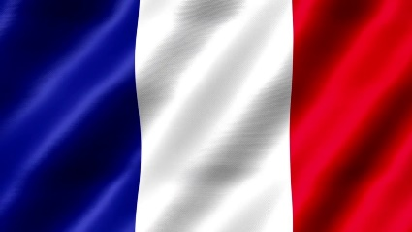

**Committee: United Nations Children's Emergency Fund  
Title: Combating Malnutrition in Underserved Children**

France is the largest state in Western Europe. It borders in the northeast with Belgium and Luxembourg, in the east - with Germany, Switzerland and Italy, in the south - with Spain. France has been a member of the United Nations (UN) since its foundation in 1945 and is one of the five countries.As France's delegate to the Model United Nations, we are deeply concerned about the problem of malnutrition among children in underserved areas. This position paper aims to find France's willingness to address this universal issue and find a comprehensive approach that will guarantee every child's right to adequate nutrition.  
  
France believes that malnutrition is an urgent problem that requires the urgent intervention of the international community and the collective action of all countries of the world. We recognize the devastating impact of malnutrition on children's growth, development, and general living conditions. The causes of malnutrition in underserved regions are poverty and socioeconomic inequality, food insecurity, limited access to healthcare, and educational disadvantages. We believe that we will contribute to the elimination of malnutrition in underserved areas, in line with our nation's values of humanism, equality, and fraternity.  
  
The proposals offered by France as a UNICEF delegate are as follows: Strong multinational cooperation. By this I mean a force that includes the governments, private sector organizations and NGOs. I am convinced that this will play an important role in the implementation of plans and practices. Another solution is also based on sustainable agriculture. France is willing to promote local production especially in areas with high levels of malnutrition. This includes investments that focus on improving access to food and developing infrastructure. France's latest solution to this consultation paper is to inform the local population and raise public awareness.

Reference:Wikipedia,MEVJMUN’24 UNICEF STUDY GUIDE