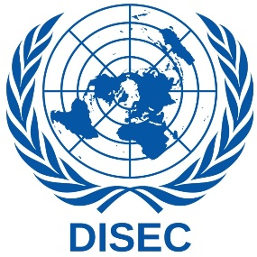
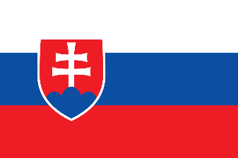
Country: Slovakia Republic
Commitee: Disarmament & Internatiional Security
Agenta Item : The Regulation of Chemical Weapon Possession and Usage

POSITION PAPER
Slovakia, officially the Slovak Republic, is a landlocked country located in Central Europe. The capital and the largest city is Bratislava with a population of approximately 440,000. Slovakia shares borders with the Czech Republic, Austria, Hungary, Poland, and Ukraine.Slovakia became an independent state on 1 January 1993 after the peaceful dissolution of Czechoslovakia, also known as the Velvet Divorce. Slovakia is a developed country with an advanced high-income economy, ranking very high in the HDI (Human Development Index).
The Slovak Republic will work on maintaining credibility and relevance of existing mechanisms for arms control, disarmament and WMD non-proliferation. It will support efforts to strengthen them in the light of the growing capacities and ambitions of states outside existing regimes, or countries applying a selective approach to fulfilling their commitments, specifically in arms control and nuclear disarmament, and commitment to chemical weapons prohibition. The Slovak Republic will support the efforts of the International Partnership against the Impunity for the Use of Chemical Weapons…

Slovakia also supports the independence and integrity of the UN Secretary General’s Mechanism for Investigation of Alleged Use of Chemical and Biological Weapons. Multilateral export control regimes are essential for the prevention of the proliferation of WMDs and their means of delivery, and they contribute to the enhancement of international peace and stability. And we believe, , in this new review cycle more prominence should be given to strategic and nuclear risk reduction efforts and promotion of transparency and accountability by the Nuclear Weapon States. . We call on relevant states to declare moratorium on production of the fissile materials for nuclear weapons and other nuclear devices

