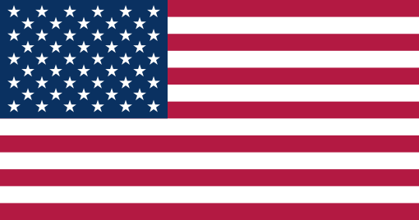**Position Paper by the Delegate of the US**

Committee: NATO

Author: Bora OĞUZ

Agenda Items: Nuclear Deterrence and Energy Security – Enhancing Cohesion: Addressing the Military Duality within the European Union

From a liberal international relations perspective, the world order might be described as an “International Anarchical Society”, as Hedley Bull coined. It is anarchical in its nature. However, there are institutions and organisations in defiance of this anarchy and, at the very least, curbing its nature. Through these institutions, which NATO is an excellent example of, it is a rules-based order and a society. In light of the recent October 7th massacre or the still ongoing illegal Russian aggression against Ukraine, it can be deduced that there are still enemies of this society and its rules. More grievous is the dependence of many current and former US allies on many of these attackers, especially in energy production and fuels. Moreover, some of these attackers hold nuclear weaponry. There is no guarantee that enemies of the free world would not resort to these weapons of mass destruction. As a defensive deterrence institution, NATO is invaluable against these illegal international and transnational attacks.

However, from another perspective, it is also possible to describe the current world order through the ”Hegemonic Stability” lens. Pax Americana still provides stability and deterrence against attacks aimed at the “free world.” NATO reports show by July 2023 show that with 3.49% of its GDP translating to 860 billion dollars US singlehandedly doubled the total spending of the rest of NATO members. The same reports also show that the major actors in Europe, like France and Germany, are spending below the agreed NATO spending of 2% per cent of their GDP, with France and Germany spending 1.9 and 1.6%, respectively.

In a combination of these facts and perspectives, the US position is clear. Nuclear deterrence is an integral part of the defence against non-rule-abiding attackers. In the same way, it is indisputable that NATO is one of the most crucial institutions of the free world against the aforementioned threats. The NATO allies first need to oblige to the numbers they have agreed for NATO, and then a European Military outside NATO can be discussed. However, in a world where the burden of defence of the free world is close to singlehandedly falls on the US, the possibility of this discussion alone is a faint one. For this reason, no US ally should forget that the collective rule of the free world is still only possible under the US leadership. Moreover, the current politics show no other possibility given the dependence of any US ally on the US, compared to vice versa. Furthermore, the energy dependence of the European NATO partners on the aggressors of the anarchical world far exceeds that of the US, which further disadvantages the US allies in an independent military situtation

In any of these endeavours, be it energy security or collective conventional security, the US is ready and willing to aid its partners and allies from its leadership position.