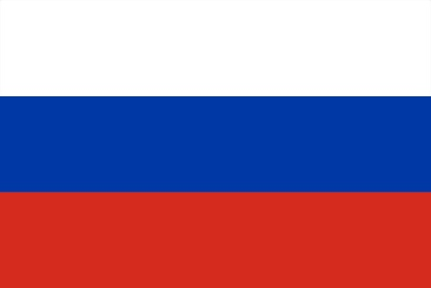**Country:Russian Federation**

**Comittee: UNDP**

**Agenda Item: Climate Crisis Adaptation and Resilience**

The Russian Federation is the largest in the world by land area. Moscow is the capital and the largest city of the Russian Federation, serving as its economic, cultural diversity, and scientific capital. The Russian Federation is a federal semi-presidential republic, with the prime minister serving as the head of the government. The Russian Federation is a member of various organizations like the United Nations, the Shanghai Cooperation Organization, and many more.

As the Russian Federation, the challenges posed by the Climate Crisis are an urgent need to address and prioritize the development of robust adaptation and resilience measures. On our large geographical area, especially in the Arctic regions, we observe the significant impact of the Climate Crisis on our environment, economy, and population. Particularly, we are facing noticeable changes such as the melting of glaciers in our Arctic Regions and the increase in extreme weather events. Therefore, we are taking resilience strategies. These include investing in sustainable energy sources and supporting environmental protection projects. Additionally, we are committed to contributing to global efforts.

The Russian Federation believes that the most important thing is to contribute to global organizations like Greenpeace, Earth Justice, and the Climate Foundation. As a country, the Russian Federation can give some priority to recycling.