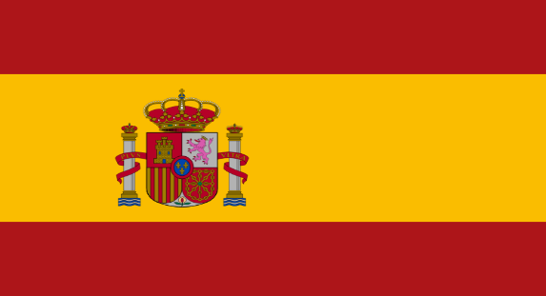 Country: Kingdom of Spain

Committee: UNESCO

Agenta Item: Preseving Cultural Heritage

Spain, or as the official name;Kingdom of Spain is a Southwestern Europe country located in the Iberian Peninsula. Being the largest country in the Southern Europe with 505,994 square kilometers of land, the country’s land also includes the Canary Islands in the Atlantic Ocean, the Balearic Islands in the Mediterranean Sea and the auotomous cities of Ceuta and Melilla in the Africa. In early antiquity, present Spain territories were inhabited by Celtic and Iberian tribes, along with other local pre-Roman population. Spain was one of the leading countries in the Age of Discovery, which pioneered the exploration of the New World and the first circunnavigation of the globe resulting the Spain becoming one of the largest empires of the history. This event’s cultural influence extended to the present-day and today Spanish is world’s second most spoken native languenge. Spain is ruled by secular parliamentary democracy and constituonal monarchy with King Felipe VI as head of state. The country has a major advanced capitalist economy system and one of the world’s largest economies.

Today protection of our cultural heritages are not a choice, but an obligation. Cultural heritages are bridges between our countries’ national identity, history and values. They connect us to our roots and provide inspiration for future generations. Unfortunately nowadays both tangible and untangible cultural heritages are being damaged all over the world. This heritages can be damaged by cultural changes, climate changes,natural disasters or simply by human hand and vandalism.

Spain is the fourth country with the highest number tangible and untangible assets recognised by UNESCO. Making the culture an essantial to the public is one of the main focuses in Spain. And thus cultural heritage managments in Spain are regulated by national law and regional legislation since1985. The law 16/1985 established a new legal framework fort he protection, enchancement and transmission to future generations of the Spanis Historical Heritage.