Country:Turkey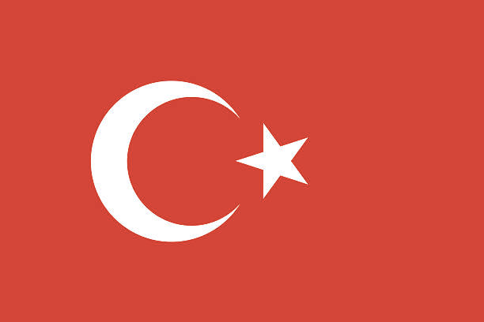

Committee:DISEC(Disarmament's & International

Security Committee

Agenda Item:Proliferation of Nuclear Weapons

in Russia-Ukrainian war

Turkey has hosted many civilizations from ancient times to the present day. The foundations of modern Turkey were laid with the establishment of the Republic of Turkey in 1923 under the leadership of Mustafa Kemal Atatürk after the War of Independence.Turkey is located at the intersection of Europe and Asia. It encompasses a large part of the Anatolian Peninsula and Thrace. The country is bordered by the Black Sea to the north, the Aegean Sea to the west, the Mediterranean Sea to the south, and the Eastern Anatolia Region to the east.

Turkey is home to various ethnic groups. It stands out with its diverse economic structure, where agriculture, industry, tourism, and the service sector form the basis of the economy. The country's geographical location and strategic importance contribute to the development of foreign trade. Turkey is governed by a parliamentary democracy. Turkey plays an active role in the international arena. The Republic of Turkey is a dynamic country with a complex and diverse history.

Turkey has a relatively short history in terms of nuclear weapons. Turkey is bound by international agreements regarding nuclear weapons and is not officially a nuclear weapons state. However, Turkey has constructed nuclear power plants for peaceful purposes. Turkey supports efforts to prevent the proliferation of nuclear weapons and is a party to international agreements in this regard. Turkey actively plays a role in nuclear disarmament and international security issues. Additionally, while taking necessary military security measures for its own national security, Turkey supports efforts to prevent the proliferation of nuclear weapons.During the Cold War period, Turkey played an important role due to its strategic location. As a member of NATO, Turkey was seen as a buffer zone against the Soviet Union. In this context, American-made Jupiter missiles were deployed in Turkey starting from the 1950s. However, as a result of the agreement with the United States during the Cuban Missile Crisis in 1962, it was decided to withdraw these missiles from Turkey.

The escalating arms race and conflict between Russia and Ukraine bring about many complex problems such as; Regional instability, human rights violations, strengthening diplomatic solutions

These problems demonstrate that the conflict could have serious consequences not only regionally but also internationally. For each problem, the following solution suggestions can be proposed; for the regional instability, measures to increase trust through diplomatic solutions and international mediation should be taken between the parties. Confidence-building measures can reduce the risk of conflict and support regional stability. Secondly, for human rights violations, the international community should adopt a clear stance condemning human rights violations and ensuring the protection of civilians. International organizations and humanitarian aid agencies should make more efforts to protect civilians and provide humanitarian assistance. And lastly, for strengthening diplomatic solutions, the international community should support diplomatic solutions and encourage the parties to sit at the negotiation table.Turkey advocates for a peaceful approach to war. As a permanent member of NATO, we are neutral in terms of war. We want peace and absolutely do not support war or militarization in wars, and we invite other countries to pursue a peaceful policy.