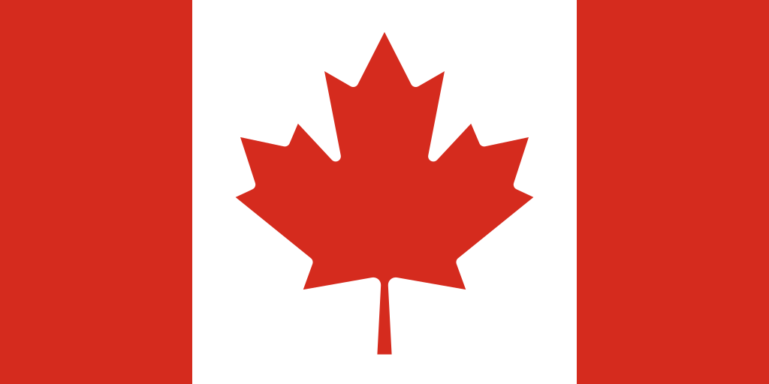Country: Canada

Commitee: UNWOMEN

Agenda Item: Women’s Medical Negligence

Canada is a country located in the northern of North America which surrounded mostly by waters. It has three neighbors. To its south is the, a close ally of Canada. In the east, the Atlantic Ocean near Newfoundland and Labrador province is where the islands of Saint Pierre and Miquelon are situated, belonging to France. These islands are the only neighbor of Canada within the European Union. Canada also shares a maritime border with Greenland in the northeast. This boundary extends over the Arctic seas. Canada and Greenland participate together on international platforms like the Arctic Council to discuss Arctic matters. The border between Canada and the USA is the longest. Canada is the world’s second largest country covering nearly 9.98 million square kilometers. This area includes various geographical features and supports diverse climates, ecosystems, and natural resources.

Women's medical neglect refers to the lack of adequate access to healthcare services or experiencing mistakes in healthcare services. This neglect can occur due to different factors such as delays in diagnosis and treatment, indifference, prejudice, and inequality. Canada is among the countries with the least neglect in this area. Canada is usually viewed as a progressive and leading country in terms of gender equality. The access to healthcare services in Canada is predominantly high, and a majority of the population can generally afford medical care. The services are financed by the federal government and managed by provinces and territories. As of 2019, as per data from the federal government, around 88% of the population in Canada had regular access to a family physician. Canada has backed UN Women by financial contributions and political commitments. It is observed globally that the conditions differ from country to country. The extent of women's neglect in medical care can fluctuate from one country to another and is frequently influenced by various factors. Nevertheless, in a few nations, women may face more challenges in accessing healthcare or medical attention. Particularly in low-income countries, women may encounter several obstacles in accessing healthcare services. These barriers can include economic limitations, educational levels, geographic distances, cultural aspects, and gender-based discrimination.

To handle this issue, the UN could draft policy proposals to remove blockades and boost women's access to healthcare services. This could cover different aspects such as lowering economic barriers, simplifying access to healthcare centers, and making sure that healthcare services are women-friendly. The UN could endorse gender sensitivity and offer training to healthcare personnel on women's health topics. This could enhance the understanding of female patients among healthcare workers and improve the services provided to them.